Present: Vickie Clark, Candy Corcoran, Wendy Church Bergstrom, Venissa Irwin, Carol Torimino, Jill Blake, Melanie Del Carlo, Tina Slowan-Pomeroy, Joanna Garneau (virtual)
- Welcome and Introductions
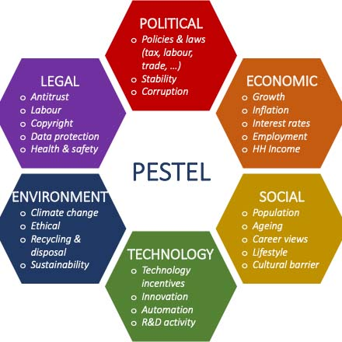
- Discussion of PESTEL root-case analysis of concept maps for the key priority area recreational activity from the two community-wide improvement plan meetings (held in Loyalton on September 26th, 2024 and in Downieville on November 21st, 2024.
- Recreational Activity (Downieville)
  - Social: perception is that there are a lot of recreational activities already; perhaps this is more of a communication issue; not everyone is comfortable using social media/technology
  - Technological: not everyone has broadband; no social media for Sierra County HHS
  - Environmental: transportation barrier, especially in winter months and on weekends
- Recreational Activity (Loyalton)
  - Economic: cost of transportation may be a barrier; cost of renting available spaces may be an issue
  - Social: getting people to attend seems to be a challenge; sustainability issue once started
  - Technological: lack of infrastructure or coordination of events; communication barrier – getting the word out
The group discussed the issue with a lack of a parks and recreation department for Sierra County; with a department focused on this issue there would be increased maintenance of outdoor space to increase outdoor recreation and activities, this would also help address the communication barrier of getting the word out community wide to events and activities that could take place in outdoor venues managed and maintained by a parks and rec department. This was categorized as a political and economic issue. Melanie explained the concept of the walking school bus to the group, and it was discussed how this could aid transportation and safety issues for children getting to school and home.
Key note: The group identified the need for a parks and recreation department in Sierra County.
There was discussion about this being more an issue of communication, coordination, and transportation than the lack of community activities. For example: it was mentioned that there are many different small groups and organizations within the county that hold events and activities, but it is not widely known to the public. There was discussion about how to get the word out, the need to break down the silos of individual organizations to work more collaboratively and closely to share resources and to coordinate activities and events together rather than separately. This would increase community member inclusion and involvement; it would also help with the communication barrier and even perhaps the transportation barriers if people could carpool and organize travel to community-wide events. Melanie mentioned the asset of Radio Remotes; the radio station that will sponsor events, bring their van to the event to advertise, and provide gift cards for prizes and raffles at local events.
There was discussion about reaching out to various organizations to partner with for events and activities such as:
- Sierra Valley Preserve (part of the Feather River Land Trust) with hiking trails and scheduled events
- Sierra Nevada Journeys (holds week-long camps and family camps at Grizzly River)
- Local 4H groups (there is the Chilcoot/Beckwith branch, the Loyalton branch, and the Sattley/Calpine/Sierraville branch) that meet once a month, hold community days each year, and organize community outreach days; mini members (ages 5-8) and regular members (ages 9-18) can join anytime with official sign ups in October each year
- Loyalton Rotary Club (holds activities and events)
Next Steps
- Tina to finalize goal statements with PHIL consultant and send them to Advisory Committee for written feedback

- March/April Community meeting -- perhaps virtual -- to:
  - Gather perspective on goal statements - Real priority is to ensure that the goals developed address root causes of the priority issues.
  - Gather perspective to create a shared vision for community
  - Ask for people to create working groups to identify & prioritize activities
It was discussed that the next community meeting be scheduled for April to have ample time to get the word out.
Venue ideas were discussed with possibilities being the Loyalton middle school, the Downieville school, the Loyalton Social Hall, and the Downieville Community Center. Spring break is the week of April 21st and the pros and cons of holding community-wide CHIP meetings this week were discussed; attendance may increase since families with children will most likely be off with kids out of school on break, but more families may also go on vacation and leave the area this week. The schools may be more available this week since school will be out for break. The auxiliary in Downieville hosts their senior lunch at the Community Center every Tuesday and it was discussed to possibly hold the meeting there following this event since many community members will already be there. Tina will need to reach out to each of these venues to determine feasibility, especially the schools to check their calendar of events.
Coordination and logistics of the community-wide CHIP meetings were discussed.
- Holding a gallery walk with easels and poster boards of the goal statements for each of the key priority areas where community members can write their thoughts, feedback, suggestions, and ideas on sticky notes to post on the boards.
- Having a poster board for increasing nutritious foods, increasing recreational activities and events as well as a poster board for community networking where we can connect the dots for how to communicate more effectively community wide.
- Organizations can have flyers, cards, posters and be available to discuss their programs and outreach to the community.
- There could be a kids’ area with activities to keep children engaged and entertained for those with families that would like to attend so there is no need or worry about childcare.
- Jill mentioned reminded us that Partnership Healthplan can provide food and refreshments. Tina will keep in contact with her about the dates and venues to coordinate.
How to get the word out about the community-wide CHIP meetings was discussed. Getting flyers to the schools to distribute to parents, asking peer support at the Wellness Center to reach out to clients, asking Deb to spread the word to older adults in her senior outreach program, asking Magdelene to reach out to older adults and community members that visit the senior center. Everyone in the advisory group can advertise and distribute flyers.
Tentative dates discussed were:
- Tuesday, April 22nd in Downieville – to follow lunch at the Community Hall or at the school (1-2:30PM)
- Thursday, April 24th in Loyalton from 5:30-7PM either at the middle school or at the Loyalton Social Hall

The next meeting will be Thursday, March 6th 9AM-11AM at the High Sierras Family Resource Center.

