Sierra County
Drought Resilience Plan
Draft
November 2025

This page left blank intentionally.

Table of Contents
1.0 Introduction 1-1
1.1 Document Organization 1-1
1.2 Legislative Requirements 1-2
1.2.1 County Agency Requirements 1-3
1.2.2 State Agency Involvement and Implementation 1-3
1.3 Purpose of Sierra County Drought Resilience Plan 1-4
1.4 Sierra County Overview 1-4
1.4.1 Demographics 1-5
1.4.2 Geography 1-5
1.4.3 Water Landscape: Supply, Use, and Management 1-6
1.4.4 Water Systems Within Sierra County’s Jurisdiction 1-8
2.0 County Drought and Water Shortage Task Force 2-11
3.0 Drought and Water Shortage Risk Assessment 3-2
3.1 Terminology 3-2
3.2 Risk Assessment Methodology 3-2
3.3 Hazards in Sierra County 3-5
3.3.1 Drought 3-5
3.3.2 Climate Change 3-6
3.3.3 Water Quality 3-7
3.4 Risk Assessment Results 3-8
3.4.1 Total Physical Vulnerability and Social Vulnerability Scores 3-8
3.4.2 Physical Vulnerability Indicators 3-12
3.5 Risk Assessment Findings 3-18
3.6 Risk Assessment Gaps 3-20
4.0 Short-Term Response Actions 4-1
4.1 Legislative Direction 4-1
4.2 Short-Term Response Actions Included in the Sierra County Drought Resilience Plan 4-1
4.2.1 Emergency and Interim Drinking Water Supplies 4-3
4.2.2 Partnership with Non-Governmental Organizations 4-4
4.2.3 Permit Streamlining and Coordination (STRA 04) 4-4
4.3 Pre-Negotiated Contracts and Mutual Aid Agreements 4-4
4.4 Drought and Water Shortage Emergency Response Process 4-5
4.4.1 Drought or Water Shortage Triggers 4-5
4.4.2 Emergency and Interim Drinking Water Distribution Plan 4-6
5.0 Long-Term Mitigation Strategies and Actions 5-1
5.1 Legislative Direction 5-1
5.2 Long-Term Mitigation Strategies and Actions Included in the Sierra County Drought Resilience Plan 5-1
5.3 Drinking Water Well Mitigation Programs 5-6
5.3.1 Communication and Outreach (LTMSA 01, 02, 03) 5-6
5.3.2 Water Shortage Prevention (LTMSA 04, 05, 06, 07, 08, 09. 10, 11) 5-7
5.3.3 Water Shortage Prevention when Permitting New or Replacement Wells (LTMSA 12) 5-9
5.4 System Consolidation 5-9
5.4.1 Existing Consolidation Opportunities (LTMSA 13) 5-9
5.4.2 Potential System Consolidation Opportunities (LTMSA 14) 5-10
5.5 Regional Water Infrastructure Investment 5-11
5.5.1 Regional Planning Integration (LTMSA 15) 5-11
5.6 Data Gaps (LTMSA 16, 17, 18) 5-13
6.0 Implementation Considerations 6-15
6.1 Legislative Direction 6-15
6.2 Implementation Roadmap 6-15
6.2.1 Monitoring and Collaboration 6-16
6.2.2 Oversight, Responsibilities, Priorities, and Resource Needs 6-17
6.3 Policy Alignment and Integration 6-21
6.4 Adaptive Management 6-22
6.5 Funding Opportunities and Assistance Programs 6-22
7.0 References 7-1
List of Figures
Figure 1-1. Hydrology Figure 1-5
Figure 1-2. Topography in Sierra County 1-6
Figure 1-3. Land Use Figure 1-6
Figure 1-4. Groundwater Sustainability Agency Monitoring Wells in Sierra County 1-8
Figure 1-5. Locations of Domestic Wells and State Small Water Systems in Sierra County 1-9
Figure 1-6. Locations of Spring-Fed Water Systems in Sierra County 1-10
Figure 3-1. Occurrence of Drought in Sierra County 3-6
Figure 3-2. Physical Vulnerability to Drought and Water Supply Shortage in Sierra County 3-9
Figure 3-3. Intersection of Physical Vulnerability and Density of Domestic Wells and State Small Water Systems in Sierra County 3-10
Figure 3-4. Social Vulnerability Scores by Census Block Group in Sierra County 3-11
Figure 3-5. Geology Indicator Showing Fractured Rock Area in Sierra County 3-12
Figure 3-6. Domestic Well Density in Fractured Rock Areas Indicator in Sierra County 3-13
Figure 3-7. Wildfire Hazard Potential in Sierra County 3-14
Table 3-3. Summary of Observed Conditions for Physical Vulnerability Indicators in Sierra County 3-15
Figure 3-8. Summary of Risk Assessment Findings Showing Areas with Water Shortage Vulnerability and Domestic Wells/State Small Water Systems in Sierra County 3-19
List of Tables
Table 1-1. Summary of Groundwater Basins, Domestic Wells, and State Small Water Systems in Sierra County 1-8
Table 2-1. Communication and Outreach for Emergency and Interim Drinking Water Distribution Process 2-1
Table 3-1. Water Shortage Vulnerability Explorer Indicators Used in the Development of Physical Vulnerability Score 3-4
Table 3-2. Water Shortage Vulnerability Explorer Indicators Used in the Development of Social Vulnerability Score 3-5
Table 4-1. List of Short-Term Response Actions Included in Sierra County Drought Resilience Plan 4-2
Table 4-2. Pre-Negotiated Contracts and Mutual Aid Agreements Recommended for Activation of Short-Term Response Actions Included in Sierra County Drought Resilience Plan (as of September 2025) 4-5
Table 4-3. Emergency and Interim Drinking Water Distribution Plan Summary 4-7
Table 5-1. List of Long-Term Mitigation Strategies and Actions Included in Sierra County Drought Resilience Plan 5-2
Table 5-2. Drinking Water Well Mitigation Programs within the County 5-6
Table 5-4. Areas with Opportunity for Domestic Wells and State Small Water Systems Consolidation 5-11
Table 5-5. Summary of Relevant Regional Planning Efforts 5-12
Table 6-1. Sierra County Drought Resilience Plan Monitoring and Collaboration Activities 6-16
Activity 6-16
Description 6-16
Activity Lead 6-16
Timing 6-16
Table 6-2. Sierra Drought Resilience Plan Short-Term Response Action and Long-Term Mitigation Strategies and Actions Implementation Summary 6-18
Table 6-3. Sierra County Drought Resilience Plan Policy Alignment and Integration 6-21
Table 6-4. Funding Opportunities and Assistance Programs for Drought Resilience Plan Implementation 6-23

This page left blank intentionally.

Introduction
The Sierra County Drought Resilience Plan (County DRP) documents how Sierra County (County), its staff (County staff), and its Drought and Water Shortage Task Force (Task Force) members, along with other entities with water supply and drought management responsibilities will address water supply vulnerabilities for three types of systems in the County: domestic wells, as defined in California Health and Safety Code (HSC) Section 116275(n) and Section 10609.51(d); state small water systems (SSWS), as defined in HSC Section 116275(n) and Section 10609.51(m); and spring-fed systems. This County DRP was prepared pursuant to Senate Bill (SB) 552: Drought Planning for Small Water Suppliers, SSWSs, and domestic well communities (Hertzberg; see Section 1.2 for additional detail). It was developed by the County with funding and technical support provided by the California Department of Water Resources (DWR) Drought Resilience Planning Assistance Program.

Document Organization
Organization of this document draws from DWR’s County Drought Resilience Guidebook (2023) (Guidebook). Consistent with the Guidebook, the County DRP is organized into six chapters:
- Chapter 1: Introduction provides an overview of the legislation relating to SB 552 and the development of the County DRP. This chapter also includes background on County demographics, geography, and an overview of domestic wells and SSWSs within the County’s jurisdiction.
- Chapter 2: County Drought and Water Shortage Task Force provides an overview of the Task Force, including its development process and charter, membership, roles, purpose, and meeting frequency.
- Chapter 3: Drought and Water Shortage Risk Assessment characterizes the vulnerability of domestic wells and SSWSs within the County to drought and water shortage. This chapter also presents the approach and data used to assess vulnerability. It highlights areas within the County that have a higher risk of drought and water shortage where domestic wells and SSWSs are present. Additionally, data gaps are identified to help inform potential long-term strategies.
- Chapter 4: Short-Term Response Actions details the proposed short-term response actions for emergency and interim drought solutions, including specific actions, local response triggers, and public engagement.
- Chapter 5: Long-Term Mitigation Strategies and Actions details the proposed long-term mitigation strategies and actions for improving the water supply resilience of domestic wells and SSWSs.
- Chapter 6: Implementation Considerations presents a roadmap for implementing short-term response actions (STRA) and long-term mitigation strategies/actions (LTMS/A) consistent with the mission and authority of involved agencies. This includes identifying agencies and entities responsible for implementation, the status of implementation, funding, authorization for implementation, and the anticipated schedule. This section also summarizes the level of multi-agency collaboration identified by agencies to support implementation.
- Chapter 7: References provides a list of references used in this plan.

Legislative Requirements
Signed into law September 2021 by Governor Gavin Newsom, SB 552 (Hertzberg) obligated the State of California (State) and local governments to share the responsibility in preparing for and responding to a water shortage event. These new requirements are expected to improve the ability of Californians to manage future droughts and help prevent catastrophic impacts on drinking water for communities vulnerable to the impacts of climate change. The bill outlines the new requirements for small water suppliers, county governments, DWR, and the State Water Resources Control Board (State Water Board) to implement more proactive drought planning and be better prepared for future water shortage events or dry years.
SB552 also implements legislation on Water Conservation and Drought Planning (SB 606 [Hertzberg] and AB 1668 [Friedman], as amended; these are collectively referred to as the “2018 Legislation”) passed by the State Legislature (Legislature). The 2018 Legislation provides a new framework for urban water use efficiency; directives for eliminating water waste; additional requirements for strengthening local drought resilience for urban areas, vulnerable small water suppliers, and rural communities; and recommendations for improving agricultural water use efficiency and drought planning.
Water users protected under SB 552 include the following:
- Small Water Supplier: A community water system serving 15 to 2,999 service connections, inclusive, and that provides less than 3,000 acre-feet of water annually (California Water Code [CWC] Section 10609.51(k)).
- Community Water System: A public water system that serves 15 to 25 service connections used by yearlong residents of the area, as defined in HSC Section 116275(i) and Section 10609.51(a).
- State Small Water System: A system for the provision of piped water to the public for human consumption that serves at least five, but not more than 14, service connections and does not regularly serve drinking water to more than an average of 25 individuals daily for more than 60 days out of the year, as defined in HSC Section 116275(n) and Section 10609.51(m).
- Domestic Well: A groundwater well used to supply water for the domestic needs of an individual residence or a water system that is not a public water system and that has no more than four service connections, as defined in HSC Section 116275(n) and Section 10609.51(d).
- Nontransient Noncommunity Water System: A public water system that is not a community water system and that regularly serves at least 25 of the same persons over six months per year, as defined in HSC Section 116275(k) and Section 10609.51(f).
For the water users protected under SB 552, this County DRP addresses water shortage vulnerabilities for domestic wells and SSWSs. Other water users protected under SB 552 not included in this County DRP have separate requirements to address water shortage vulnerabilities.

County Agency Requirements
This County DRP fulfills County requirements for preparation of a plan that includes potential drought and water shortage risk and proposed interim and long-term solutions for domestic wells and SSWSs within the County’s jurisdiction (CWC Section 10609.70). While measures to protect small water suppliers and nontransient noncommunity water systems are not within the scope of this document, this plan considers integration opportunities consistent with the intent of SB 552. Applicable County requirements are:
- Establish a standing County Drought and Water Shortage Task Force (CWC Section 10609.70(a))
- Develop a plan that considers, at a minimum, each of the following (CWC Section 10609.70(b)):
- Consolidations for existing water systems and domestic wells
- Domestic well drinking water mitigation programs
- Provision of emergency and interim drinking water solutions
- An analysis of the steps necessary to implement the plan
- An analysis of local, State, and federal funding sources available to implement the plan

State Agency Involvement and Implementation
SB 552 defined a series of requirements for the State Water Board and DWR. These include:
State Water Resources Control Board (CWC Section10609.70(c)):
The state board shall work with counties, groundwater sustainability agencies, technical assistance providers, nonprofit organizations, community-based organizations, and the public to address state small water system and domestic well community drought and emergency water shortage resiliency needs, including both of the following:
(1) Proactive communication to domestic well communities before a drought occurs, such as information on local bottled water and water tank providers.
(2) Funding for installation of basic drought and emergency water shortage resiliency infrastructure, such as well monitoring devices.
California Department of Water Resources (CWC Section 10609.80(a)):
The department shall take both of the following actions to support implementation of the recommendations of its County Drought Advisory Group:
(1) Maintain, in partnership with the state board and other relevant state agencies, the risk vulnerability tool developed as part of the County Drought Advisory Group process and continue to refine existing data and gather new data for the tool, including, but not limited to, data on all of the following:
(A) Small water suppliers and nontransient noncommunity water systems serving a school.
(B) State small water systems and rural communities.
(C) Domestic wells and other self-supplied residents.
(2) Update the risk vulnerability tool for small water suppliers and rural communities periodically, by doing all of the following:
(A) Revise the indicators and construction of the scoring as more data becomes readily available.
(B) Make existing and new data publicly available on the California Open Data internet web portal.
(C) In consultation with other relevant state agencies, identify deficits in data quality and availability and develop recommendations to address these gaps.
(b) (1) The department, in collaboration with the state board and relevant state agencies, shall establish a standing interagency drought and water shortage task force to facilitate proactive state planning and coordination, both for predrought planning and post-drought emergency response, to develop strategies to enhance collaboration between various fields, and to consider all types of water users.
(2) The interagency drought and water shortage task force shall include representatives from local governments, community-based organizations, nonprofit technical assistance providers, the public, and experts in land use planning, water resiliency, and water infrastructure.

Purpose of Sierra County Drought Resilience Plan
The County DRP documents how the County, Task Force members, and other entities with water supply and drought management responsibilities intend to address water supply vulnerabilities of water users protected under SB 552 in the County. It is a single document for ease of reference and for future updates. It describes the water shortage vulnerabilities present in the County, the responses to identified vulnerabilities, and the policy, financial, and regulatory considerations necessary for the implementation of the County DRP. Implementation of the County DRP is led by the County Office of Emergency Services in close coordination with other departments, including the County Department of Building and Planning, the County Department of Public Works, and the County Department of Environmental Health.
This County DRP was developed by the County with funding and technical support provided by DWR’s Drought Resilience Planning Assistance Program. It conforms to the legislative requirements of SB 552.

Sierra County Overview
Sierra County is located in the Sierra Nevada Mountain Range in Northern California and is the State’s second least populated county (USCB 2025). The County seat, Downieville, is located 106 miles from Sacramento.

Demographics
Selected demographics of the County are summarized below per the 2020 Census and 2022 American Community Survey (ACS) (USCB 2020).
- Population: The County has a population of 3,236 people. It is a rural area composed of small communities; all residents live in rural areas or towns. Notable towns include Alleghany, Calpine, Downieville, Goodyears Bar, Loyalton, Sierra City, and Sierraville.
- Age: The County has a median age of 54.9. Around 15 percent of the population is under 18 years old, while 32 percent is 65 years and over.
- Ethnicity: The three largest ethnic groups in the County are White (Non-Hispanic) (80.8 percent), Hispanic or Latino (11.7 percent), and Other (Non-Hispanic) (0.77 percent).
- Household Income: The median household income of the County, per the 2022 ACS five-year estimates is $61,108. This is a 8.11 percent increase from the $56,152 median in 2021.
- Education: The County has a lower-than-average percentage of residents 25 years or older with a bachelor's degree or higher at around 23.9 percent, compared to 37 percent for California overall.
- Poverty Level: About 12.6 percent of the population in the County live below the poverty line, a number that is higher than the national average of 12.6 percent. The largest demographic living in poverty are residents under 18 years of age, followed by those 65 years and older, followed by those in between. Females experience poverty at a slightly higher rate than males. The most common racial or ethnic group living below the poverty line in the County is White, followed by American Indian or Alaska Native.

Geography
The County is a mountainous region with lakes and reservoirs and the headwaters of several rivers. The majority of the County is forestland, with cattle, pasture, forest products, and alfalfa serving as the leading agricultural commodities. Farm gate value of agricultural crops in the County totaled $17.01 million in 2023 (California Department of Food and Agriculture 2023-2024 California Agricultural Statistics Review.
Hydrology
Three hydrologic subregions overlay Sierra County; they include the Sacramento, North Lahontan, and Central Lahontan Subregions (U.S. Geological Survey), as shown in Figure 1-1. The Sacramento Subregion overlays the majority of Sierra County, with the North and Middle forks of the Yuba River representing the largest watersheds within it. There are also many tributaries and streams. Major lakes and reservoirs include Gold Lake, Sardine Lake, Webber Lake, Stampede Reservoir, and the northern portion of Jackson Meadows Reservoir.
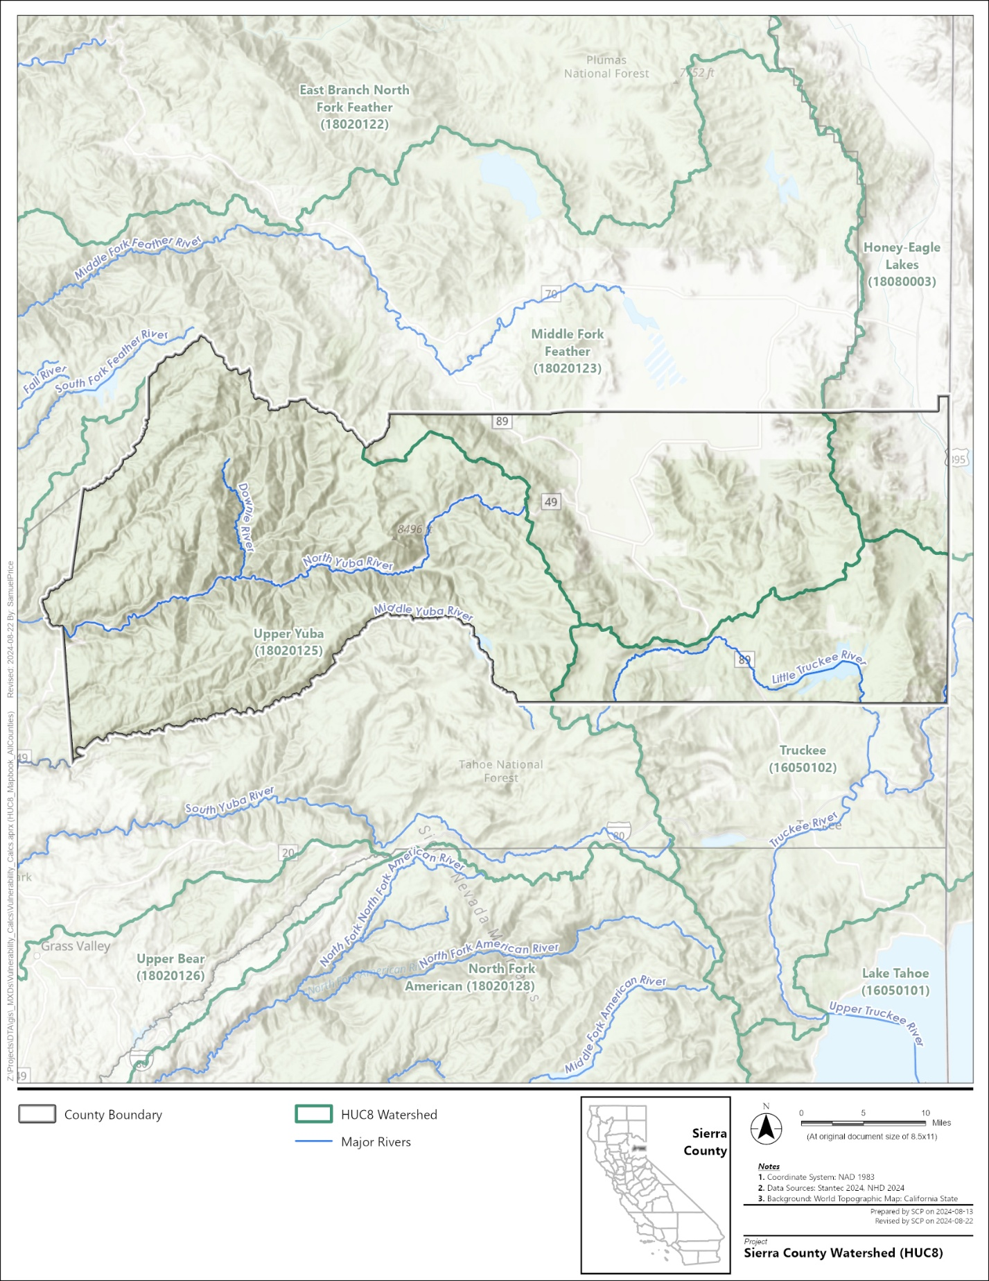
Figure ‎1-1. Hydrology in Sierra County
Precipitation
A monitoring station in Downieville, located in the western mountainous portion of the County, reports an annual average precipitation of approximately 65 inches (USFG 2023). Modeled historical data indicates that the 30-year average precipitation in the County is 51.3 inches (Cal-Adapt 2018), 54.2 percent above the California average of 23.5 inches (OEHHA 2024).
Topography
The County’s topography is depicted in Figure 1-2. With an average elevation of 5,544 feet, the County is primarily mountainous as it lies within the Sierra Nevada Mountain Range. However, some flatlands are present in the Sierra Valley and in the far northwestern corner of the County.
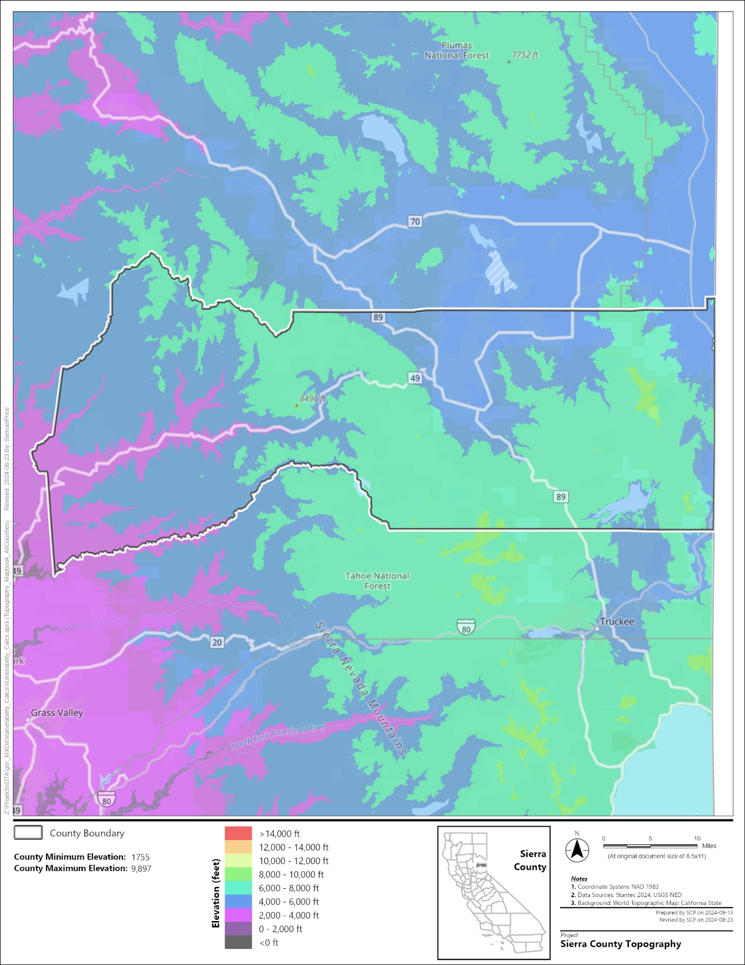
Figure ‎1-2. Topography in Sierra County
Land Use
The County is largely undeveloped forestland with some farmland and rural towns, as shown in Figure 1-3. Agriculture occurs primarily in the Sierra Valley and Long Valley Groundwater Basin regions, where the majority of farmland is categorized as pastureland and grain and hay crop production areas (DWR Land Use Viewer 2023). Around two-thirds of the land area is managed by the U.S. Forest Service (BLM National Data 2024).
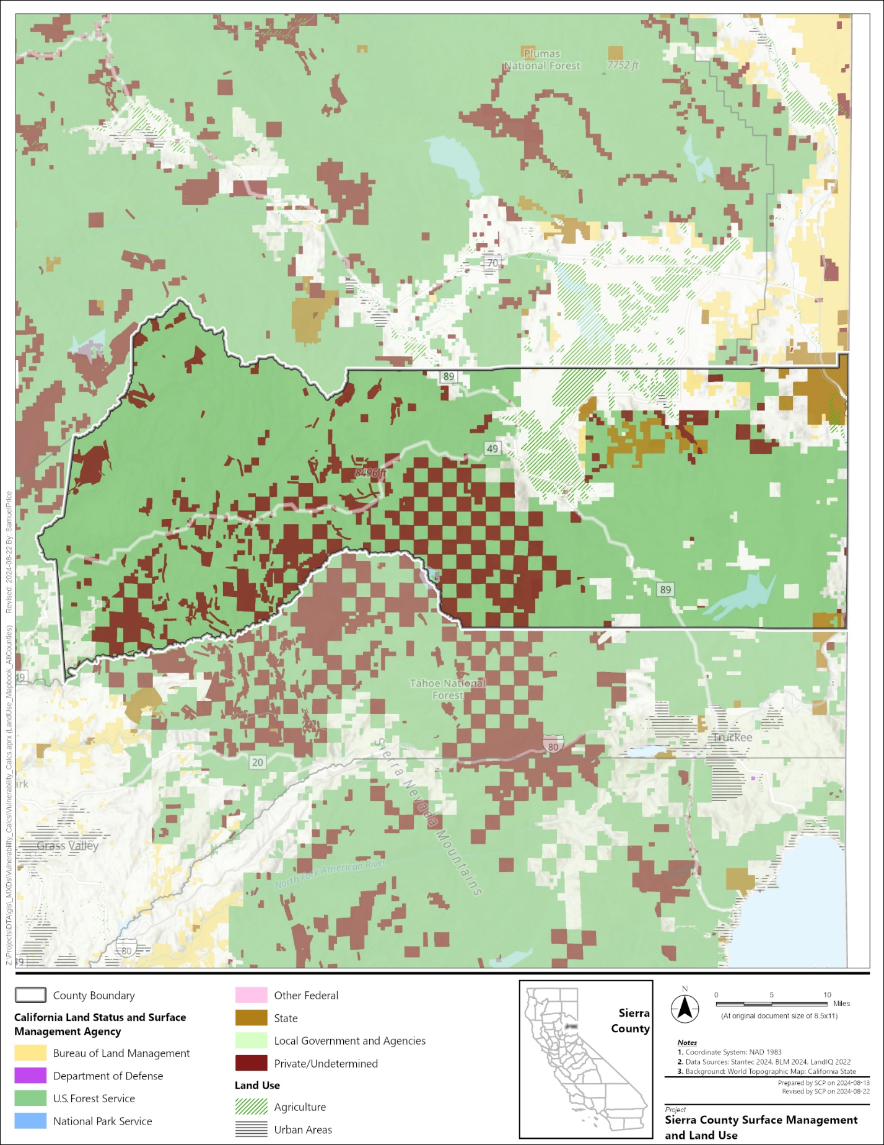
Figure ‎1-3. Land Use in Sierra County
Geology
With its location on the 460-mile-long Sierra Nevada Mountain Range, the County is situated in a region dominated by granite, metamorphosed sedimentary rocks, and extrusive rocks. Major features within the County include the Sierra Buttes, a metavolcanic rock formation that rises to 8,591 feet, and the Sierra Valley, an intermontane valley at approximately 4,850 feet elevation. Covering about 590 square miles, the Sierra Valley is a down-faulted basin and former lake now filled with sediment up to 2,000 feet thick. A portion of the County also lies in the Long Valley Groundwater Basin, a 73-square-mile region along the California-Nevada border that extends north into Lassen County. Sediments in Long Valley that feed the majority of local groundwater wells are comprised of sandy pebbles and cobbles.

Water Landscape: Supply, Use, and Management
Water supplies for domestic, industrial, agricultural, and environmental uses within the County are described below.
Water Supplies:
- Groundwater: Groundwater represents the primary water supply resource for beneficial uses in the County. The region includes three alluvial groundwater basins, including the Sierra Valley Groundwater Basin (Sierra Valley Basin), the Mohawk Valley Groundwater Basin, and the Long Valley Groundwater Basin. The remaining groundwater resources include fractured rock regions (DWR 2024b), where precipitation recharges supply more readily than in the basin regions, though overall supply availability can be unpredictable (DWR 2025).
- Surface Water: Surface water is the other major source of water supply, with the North Yuba River and its tributaries being the primary source. A network of spring-fed streams provides domestic water to several households in the County (see Figure 1-4).
Water Uses:
- Agriculture: Agriculture is the primary water user in the County, concentrated in the Sierra Valley. Agriculture in the County includes farmland and grazing land (Sierra Valley Groundwater Management District [SVGMD] and Plumas County 2022). Key crops include cultivated Christmas trees and short-rotation woody crops, grains, oilseeds and dry legumes, and hay (USDA 2022).
- Municipal and Domestic: There are 34 public water systems in the County, primarily serving noncommunity populations (State Water Board 2020). In addition, many primary residences, vacation homes, recreational resorts, and campgrounds use domestic wells, SSWSs, or spring-fed systems for water supply.
Water Management Actions:
- Groundwater Sustainability Plan (GSP): The Sierra Valley Basin is a medium-priority groundwater basin subject to the Sustainable Groundwater Management Act. The County, in partnership with Plumas County, prepared and adopted a GSP in 2022.
- Recycled Water Initiatives: Recycled water is produced at the Whitehawk Ranch Wastewater Treatment Plant in Loyalton (State Water Board 2023).
- Drought Preparedness: The County has a water conservation policy that specifies four phases regulating outdoor use during drought conditions that can be enforced by the County.
Groundwater Detail
The County contains three Bulletin 118 subbasins: the southern half of the Sierra Valley Groundwater Basin (DWR Basin Number 5-012.01), a small portion of the southern Mohawk Valley Groundwater Basin (DWR Basin Number 5-011), and the southwestern portion of the Long Valley Groundwater Basin (DWR Basin Number 6-104). Analysis completed by DWR to support implementation of the Sustainable Groundwater Management Act (SGMA) classified the Sierra Valley Basin as a medium-priority subbasin, and the other basins as low-priority basins. The remainder of County groundwater supplies are in fractured rock basins (DWR 2024b).
The SVGMD manages the Sierra Valley Basin and prepared its Groundwater Sustainability Plan (Sierra Valley GSP), which was adopted in 2022. There are 37 GSP monitoring wells in the Sierra Valley Basin, 14 of which are in the County, as shown in Figure 1-4. The GSP identified management actions to improve groundwater sustainability, including improved monitoring, agricultural efficiency improvements, groundwater trading system development, and aquifer recharge (SVGMD and Plumas County 2022).

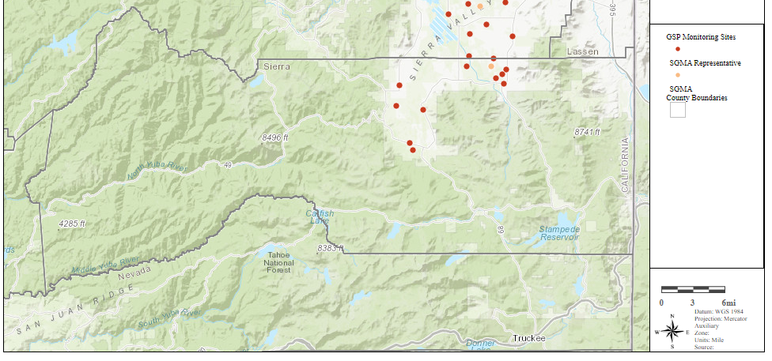
Source: https://sgma.water.ca.gov/webgis/?appid=SGMADataViewer#gwlevels, Accessed: 8/2024
Figure ‎1-4. Groundwater Sustainability Agency Monitoring Wells in Sierra County

Water Systems Within Sierra County’s Jurisdiction
SB 552 requires the County DRP to include domestic wells and SSWSs. Figure ‎1-5 shows the location of domestic wells and SSWSs within the County, and Table 1-1 summarizes how many domestic wells and SSWSs are in the Bulletin 118 basins and fractured rock areas. In addition, this figure and table show domestic wells that are outside the County but still within groundwater basins that are within the County. In addition, the County has households that receive water from spring-fed systems, with the general locations of these systems shown in Figure ‎1-6. These spring-fed systems are not covered under other planning efforts and are included in this County DRP.
Table 1-1. Summary of Groundwater Basins, Domestic Wells, and State Small Water Systems in Sierra County
Bulletin 118 Basin ID | Groundwater Basin Name | SGMA Priority | Domestic Wells Drilled After 1977¹ | Domestic Wells Drilled Before 1977¹ | State Small Water Systems | Domestic Wells in Basin but Outside County
5-011 | Mohawk Valley | Very Low | 0 | 0 | 0 | 547
5-012.01 | Sierra Valley | Medium | 158 | 22 | 1 | 307
6-104 | Long Valley | Very Low | 6 | 0 | 0 | 71
N/A | Fractured Rock Aquifer | N/A | 261 | 38 | 4 | N/A
Total |  |  | 425 | 60 | 5
¹ Information presented in this table and figure are based on well completion reports. Geographic information on well completion reports may be inaccurate and/or place the well not at the actual well location. As a result, the number of domestic wells may be overestimated, and the placement of wells may not reflect actual locations.

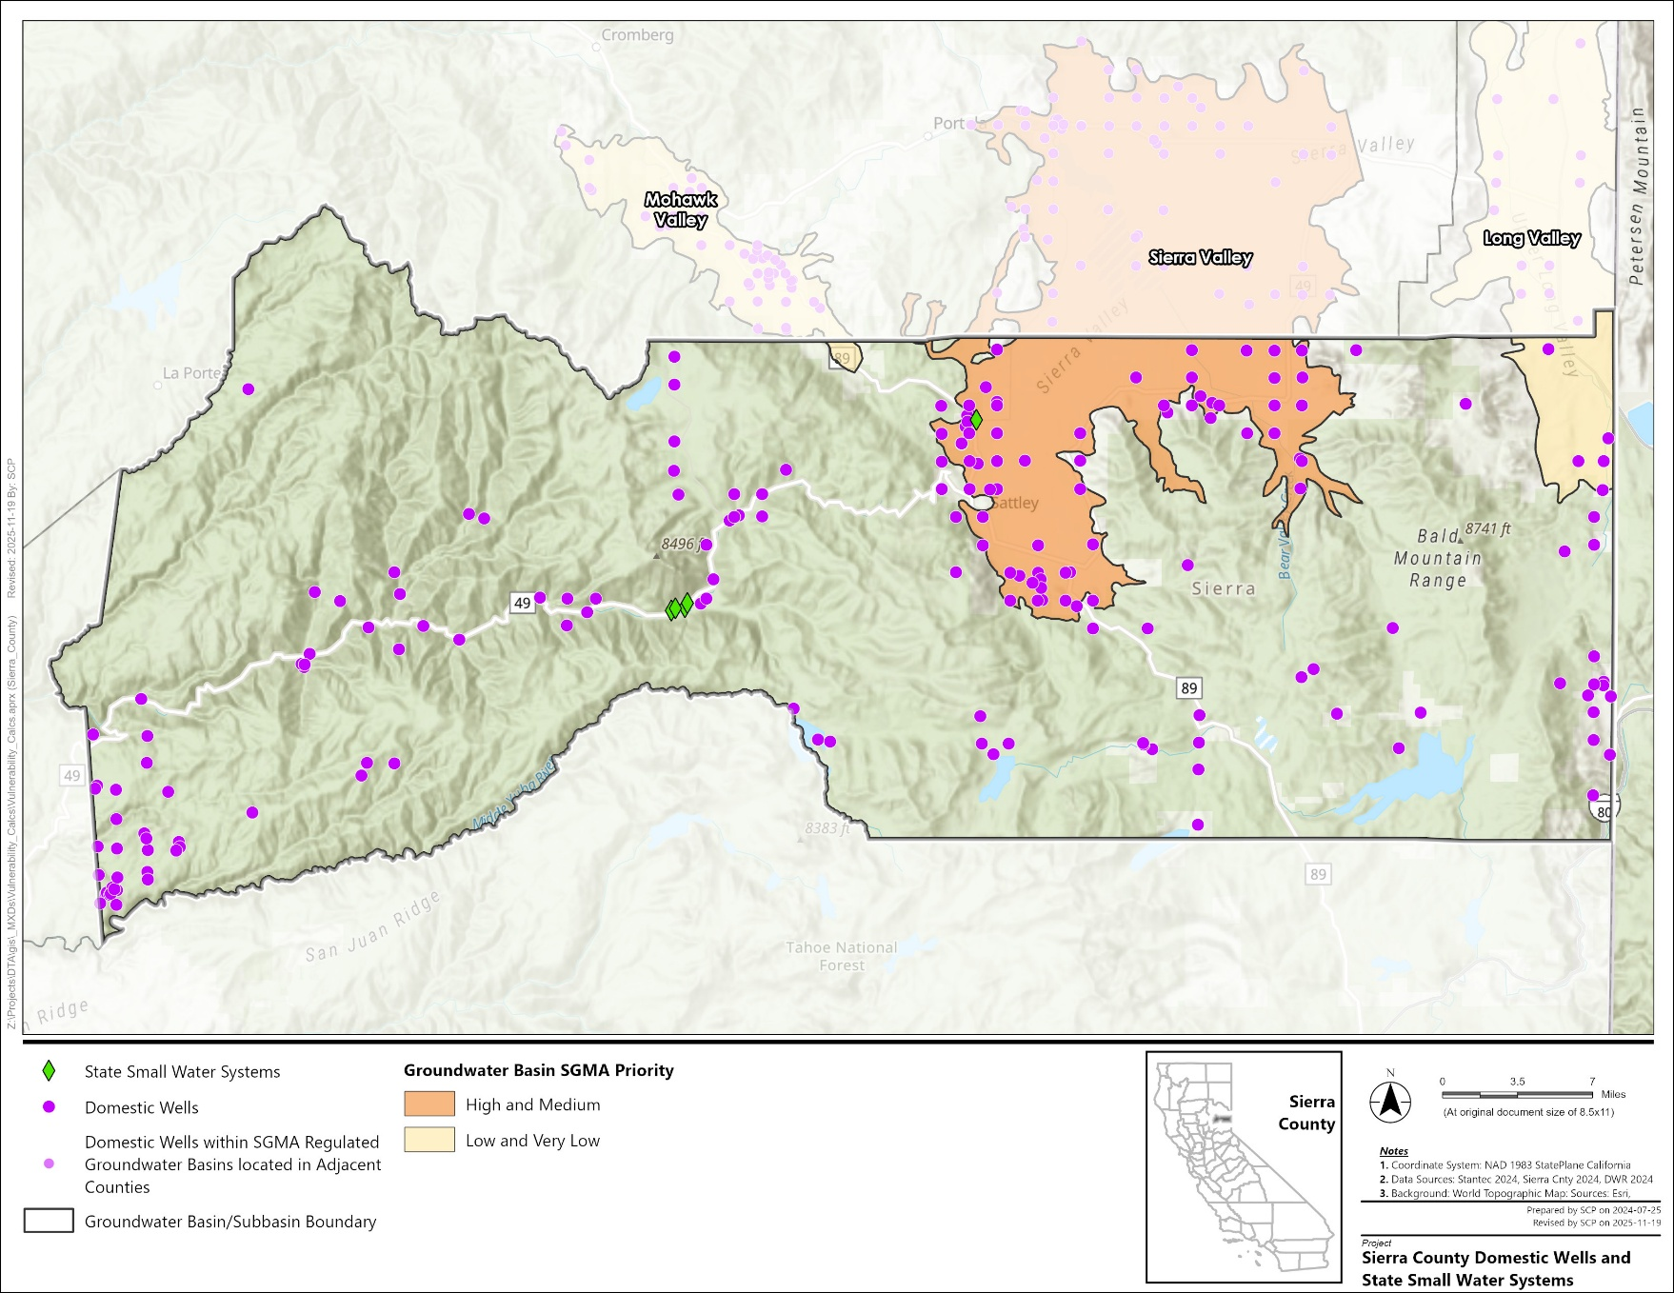
Figure ‎1-5. Locations of Domestic Wells and State Small Water Systems in Sierra County
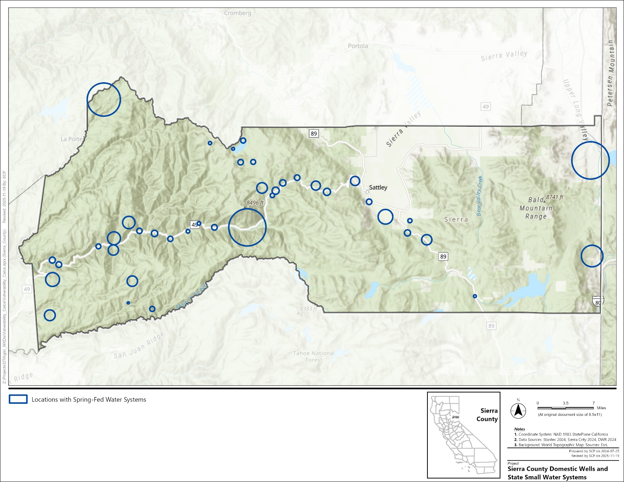
Figure ‎1-6. Locations of Spring-Fed Water Systems in Sierra County

County Drought and Water Shortage Task Force
This section describes the Task Force that was established in support of the County DRP and the activities done to communicate and collaborate with the State and local governments, the SVGMD, community-based organizations, local water suppliers, and local residents. The Task Force Charter developed for the Task Force is included in Appendix A.

Purpose and Goals
The purpose of the County Drought and Water Shortage Task Force (Task Force) Charter (Charter) is to:
- Establish the authority, scope, and structure of the Task Force, a standing body established pursuant to Senate Bill (SB) 552 and CWC Section 10609.70
- Define the organization structure of the Task Force for development, revision, and implementation of the Sierra County Drought Resilience Plan (County DRP), as described further in Chapter 3
- Describe additional Task Force communication and engagement efforts related to the County DRP, as described in Chapter 4
- Identify and define additional information needed for establishing the Task Force within the County’s standing committee framework, as described in Chapter 5
The Task Force seeks to achieve the following goals:
- Facilitate drought and water shortage preparedness for domestic wells and SSWSs within the County’s jurisdiction
- Facilitate regular coordination and communication among the staff of relevant County departments, local water agencies, local water suppliers, the SVGMD, and others representing the concerns of domestic wells and SSWS users
- Develop a County DRP that supports drought and water shortage preparedness and responsiveness for domestic wells and SSWSs within the County’s jurisdiction
- Support implementation of the County DRP

Legislative Direction
In September 2021, SB 552 (Hertzberg) was enacted to address, among other things, water shortage risks faced by small water suppliers and domestic well users during drought and water shortage events. Under SB 552, counties are required to prepare a County DRP to achieve meaningful long-term improvements in water resilience for domestic well and SSWS communities.
Passage of SB 552 mandates establishment of a standing Task Force to cultivate the continued practices of drought planning and improving long-term water resilience. Composition of the Task Force is guided by CWC Section 10609.70 (a)(1) and (2):
(a)(1) A county shall establish a standing county drought and water shortage task force to facilitate drought and water shortage preparedness for state small water systems and domestic wells within the county's jurisdiction, and shall invite representatives from the state and other local governments, including groundwater sustainability agencies, and community-based organizations, local water suppliers, and local residents, to participate in the task force.
(2) In lieu of the task force required by paragraph (1), a county may establish an alternative process that facilitates drought and water shortage preparedness for state small water systems and domestic wells within the county's jurisdiction. The alternative process shall provide opportunities for coordinating and communicating with the state and other local governments, community-based organizations, local water suppliers, and local residents on a regular basis and during drought or water shortage emergencies.
The County Task Force has been established pursuant to CWC Section 1609.70(a)(1). The composition, roles, and responsibilities defined in this Charter are intended to fulfill the County’s obligations under SB 552.

Organization
The Task Force is a community- and agency-based body that is focused on water shortage vulnerabilities and water supply reliability of domestic wells and SSWS communities. Figure 2-1 illustrates the decision-making framework of the Task Force in relation to the County Board of Supervisors and County staff.

County Board of Supervisors
The County Board of Supervisors adopts the County DRP and approves implementation actions requiring board-level decisions and funding actions. The Board of Supervisors also reviews recommendations provided by the Project Coordination Team (PCT) and the Task Force.

Project Coordination Team
The PCT is comprised of County offices and departments responsible for the preparation, revision, and implementation of the County DRP. The PCT is led by the County Office of Emergency Service (County OES). Additional participating County departments include Public Works/Roads and Environmental Health, Planning, and Building.
Unless otherwise agreed upon, County OES leads engagement efforts with the Board of Supervisors. The PCT may be supported by additional entities as needed.
The PCT’s responsibilities include:
- Lead and manage the preparation and revision of the County DRP
- Convene, collaborate, and respond to informational needs of the Task Force in relation to the preparation, revision, implementation, and adoption of the County DRP
- Support the Task Force in the conduct of annual and emergency meetings
- Coordinate revision and adoption of the County DRP with the Board of Supervisors consistent with County policies and regulations
- Lead and coordinate implementation of the County DRP by County agencies and other partner agencies
- In collaboration with the Task Force, lead communication and engagement activities with County DRP interested parties
- Evaluate and accept non-County parties as PCT members where such parties serve as implementation partners of the County DRP

Drought and Water Shortage Task Force
The Task Force, shown in Figure ‎2-1, is a standing body established pursuant to CWC Section 10609.70(a)(1) and formed administratively by the PCT. The Task Force is an advisory and consultative entity to the County Board of Supervisors and the PCT.
Pursuant to CWC Section 10609.70, invited Task Force members included representatives of one or more of the following interest groups:
- State and local government entities, including groundwater sustainability agencies
- Community-based organizations
- Local water suppliers
- Local residents, including operators of domestic wells and SSWSs

Sierra County Board of Supervisors
Sierra County Office of Emergency Services
Project Coordination Team
County Department of Environmental Health
County Department of Planning and Building
County Department of Public Works/Roads
County Office of Emergency Services
Drought and Water Shortage Task Force
- City of Loyalton
- County Board of Supervisors Representative
- Community Service District
- Domestic Well Owners
- Sierra Valley Groundwater Management District
- State Water Resources Control Board
- State Small Water System Representative
Figure ‎2-1. Structure of Parties Involved in Sierra County Drought and Water Shortage Task Force.

Communication and Engagement
In developing the County DRP, the County conducted various communication and collaboration activities to gather input. These activities included:
- Task Force Meetings: Four Task Force meetings were held to review incremental progress of the County DRP development.
- Website: The County established a website for domestic well and SSWSs that, throughout DRP development, hosted draft documents, notifications of upcoming presentations, and other relevant information for DRP development.
- Notifications: The County communicated its website and Task Force meetings using established social media channels.

Drought and Water Shortage Risk Assessment
A drought and water shortage risk assessment (referred to as the risk assessment) was prepared in development of the County DRP as directed in CWC Section 10609.70(b). This risk assessment evaluated how potential hazards intersect with the County’s domestic well and SSWS assets and other community assets, to characterize the vulnerability of domestic wells and SSWSs to water supply shortage. The outcomes from the risk assessment helped inform response plans with short-term actions to employ when a water supply shortage occurs and long-term mitigation strategies and actions that reduce vulnerability to water shortages. This chapter presents the risk assessment results for the County.
The risk assessment presented in this County DRP does not replace the regulatory requirements of the Federal Emergency Management Agency (FEMA). The County DRP could make the County eligible for FEMA’s Pre-Disaster Mitigation and Hazard Mitigation Grant programs. However, if a jurisdiction also seeks approval of the drought and/or water shortage risk assessment within the Local Hazard Mitigation Plan, it should follow the requirements outlined in the FEMA Local Mitigation Planning Handbook (FEMA 2013).

Terminology
The County DRP adapted the following definitions from the FEMA Local Mitigation Planning Handbook (FEMA 2013) within the context of drought and water shortage planning:
- Community assets: The people, structures, facilities, and systems that have value to the community. The minimum assets considered as part of the SB 552 plan include domestic wells, SSWSs, and populations relying on those water supplies.
- Hazard: A source of harm or difficulty created by a meteorological, environmental, geological, hydrological, or other event conditions. In the context of SB 552, hazards are the natural, human-made, and social processes that can lead to water shortages in the County.
- Impact: The consequences or effects of a hazard related to drought and water shortages on the community and its assets.
- Risk: The potential for damage, loss, or other impacts (e.g., water shortage) created by the interaction of natural hazards with community assets and their physical and social vulnerabilities.
- Risk Assessment: A product or process that collects information and assigns values to risks for the purpose of informing priorities, developing or comparing courses of action, and informing decision making.
- Vulnerability: Characteristics of community assets or populations that make them susceptible to damage from a given hazard. It includes both physical vulnerability and social vulnerability.

Risk Assessment Methodology
The nature and severity of hazards that can cause water shortages vary at regional and local scales due to differences in conditions such as precipitation patterns, groundwater levels, topography, geology, infrastructure, regulatory frameworks, and other conditions. Communities lacking access to reliable water sources are most vulnerable to water shortage caused by such hazards. To address this, a thorough risk assessment was completed that considered many physical and social hazard indicators. The results and findings of that risk assessment were then used by the County and Task Force to develop actions and strategies to address water shortages (see Chapters 4 and 5).
The risk assessment was completed following the four steps outlined below.
- Describe Major Hazards in the County: Drought, climate change, and water quality hazards were summarized and described.
- Complete Draft Risk Assessment using DWR Water Shortage Vulnerability Explorer: The DWR Water Shortage Vulnerability Explorer Tool (WSVE Tool) was used to (a) identify areas within the County where domestic wells and SSWSs are vulnerable to water supply shortages, and (b) characterize the hazards driving vulnerability. This information was included in a draft risk assessment. The County and the Task Force reviewed the draft risk assessment, provided feedback, and identified data gaps. Additional detail on the WSVE Tool and how it was applied in the risk assessment is included below.
- Revise the Draft Risk Assessment: County and Task Force feedback on the draft risk assessment was used to develop a revised risk assessment.
- Incorporate Results of Revised Risk Assessment into the County DRP: Information from the revised risk assessment was included in the County DRP (Section 3.4). Findings from the revised risk assessment were used by the County and Task Force to develop short-term actions and long-term strategies to improve water supply sustainability (Chapters 4 and 5).
Developed by DWR in collaboration with the County Drought Advisory Group (CDAG), the WSVE Tool is an online geospatial tool that quantifies hazards using spatially visualized indicators. There are both indicators of physical vulnerability (Table 3-1) and social vulnerability (Table 3-2). These indicators were selected by DWR and the CDAG to reflect the hazards that could make a domestic well or an SSWS vulnerable to water supply shortage.
The WSVE Tool calculates both a total physical vulnerability score and a total social vulnerability score, each combining the associated individual indicators. The process used by the WSVE Tool to calculate those total scores is summarized below.
- The total physical vulnerability score was calculated at the Public Land Survey Section (PLSS) scale by normalizing the indicator value between 0 and 1, with 1 representing the highest possible vulnerability. Normalized scores were multiplied by a weighting factor from 1 to 5 that was assigned by DWR and the CDAG to capture how some indicators contribute more than others to water shortage vulnerability.
- The total social vulnerability score was calculated at the Census Block Group (CBG) scale by normalizing the indicator value between 0 and 1 and summing the values together without additional weighting.
DWR periodically revises the WSVE Tool to incorporate improved data and/or updated methodology. Data for the risk assessment was accessed in July 2025 and used the 2024 methodology. The detailed methodology that describes the WSVE Tool indicators and corresponding values, data sources, and the weighting factors is available on the California Natural Resource Agency’s Open Data Portal.
Table 3-1. Water Shortage Vulnerability Explorer Indicators Used in the Development of Physical Vulnerability Score
Indicator Name¹ | Indicator Description
Climate Change
Temperature Shift (RC1a) | Projected change in max temperatures by midcentury.
Saline Intrusion Projected (RC1b) | Spatial extent of projected 1-meter sea level rise by 2040 into coastal aquifers.
Wildfire Risk (RC1c) | Projected area burned by 2035–2064.
Current Environmental Conditions and Events
2024 Precipitation (RC2a) | If 2024 precipitation was less than 70% of normal.
Multiple Dry Years (RC2aa) | Count of dry years within the last 5 years.
Wildfire Risk (RC2b) | CalFire Hazard Score.
Geology (RC2c) | Fractured rock basin within the PLSS.
Water Quality Aquifer Risk (RC2i) | SAFER Needs Assessment 2022 water quality composite score.
Subsidence (RC2d) | Amount of subsidence as measured by remote sensing.
Basin Salt (RC2e) | Presence of saltwater intrusion into coastal aquifer.
Overdrafted Basin (RC2f) | SGMA critically overdrafted groundwater basin.
Chronic Declining Water Levels (RC2g) | Amount of declining groundwater levels between 2019 and 2022.
Surrounding Land Use (RC2j) | Proportion of irrigated agriculture in PLSS
Infrastructure Susceptibility
Dry Domestic Well Susceptibility in basins (RC3a) | Dry well susceptibility
Domestic Well Density in Fractured Rock Areas (RC3c) | Density of Well Completion Reports
Record of Shortage
Reported Household Outage on Domestic Well | Presence of 1 or more households with reported outages in PLSS
Notes:
¹ Abbreviations are included next to Indicator Name (i.e., “RC1a”) for clarity to underlying methodology
CalFire = California Department of Forestry and Fire Protection
Key: PLSS = Public Land Survey Section
SAFER = Safe and Affordable Funding for Equity and Resilience Program
SGMA = Sustainable Groundwater Management Act
Table 3-2. Water Shortage Vulnerability Explorer Indicators Used in the Development of Social Vulnerability Score
Indicator Name | Indicator Description
Socioeconomic Status
Poverty Level | Percent of persons below poverty level
Unemployment | Percent of persons aged 16 years of age or older that are unemployed
Per Capita Income | Per capita income
Language and Education
Education Attainment | Percent of persons without a high school diploma
English Language Proficiency | Percent of persons who speak little to no English
Demographics
Elderly Population | Percent of persons 65 years of age or older
Non-Adult Population | Percent of persons 17 years of age or younger
Minority Population | Percent of persons that are in a minority population
Disability | Percent of persons 5 years of age or older with a disability
Single-Parent Households | Percent of single-parent households
Housing and Transportation
Multi-Unit-Housed Population | Percent of persons living in a multi-unit structure
Mobile Home–Housed Population | Percent of persons living in a mobile home
Crowded Conditions | Percent of persons living in conditions with more than one person in a room
No Vehicle Access | Percent of households with no vehicle available
Housing and Transportation
Persons of Color | Percent of persons that identify with a race other than White or identify ethnically as Hispanic or Latino

Hazards in Sierra County
This section summarizes the recent drought, projected climate change, current water quality, and groundwater hazards in the County. Section 3.4 provides more detail on the vulnerabilities related to these hazards.

Drought
Since 2000, the County has experienced periods of drought ranging from “Abnormally Dry” to “Exceptional Drought” as defined by the U.S. Drought Monitor, and depicted in Figure 3-1. Drought follows a cyclical nature within the County, where periods of Exceptional Drought are followed by periods without drought, and where drought can onset rapidly, sometimes within a single year. The recurrence and severity of drought in the County demonstrate that it is an important hazard to consider in the risk assessment.
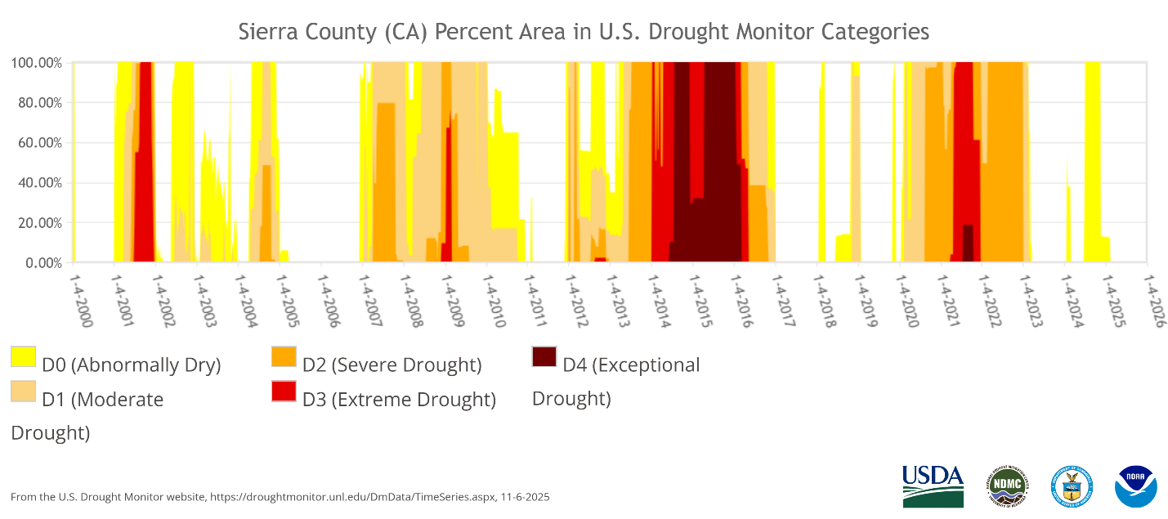
Source: https://droughtmonitor.unl.edu/DmData/TimeSeries.aspx, Accessed: 11/2025
Figure ‎3-1. Occurrence of Drought in Sierra County

Climate Change
According to California’s Fourth Climate Change Assessment, climate change has increased both average temperatures and the frequency and intensity of heat waves or extreme heat events. While global temperature increases are between 1.8 and 3.6°F, local observed increases that affect neighborhoods and ecosystems are more variable and often of greater magnitude. The Sierra Nevada Region Report subsection, which includes the Sierra County region, predicted an approximate increase of 3 to 4°F under leveling greenhouse gas concentrations, or 9°F under increasing greenhouse gas concentrations (Dettinger et al. 2018).
Droughts in California are triggered by a lack of large winter storms, and water shortages are further exacerbated by high temperatures, which increase the evaporative loss of water from soils, rivers, canals, and reservoirs. Ongoing Drought conditions can cause mental and physical stress in people, reduce the number of workable farm-labor days, and lead to deteriorated air and water quality (Greene 2018; Barreau et al. 2017).
Historical data show that daily precipitation extremes have intensified in most areas of the country, including California. As the atmosphere continues to warm, extreme precipitation events could become more frequent as storms can hold about six to seven percent more water for each degree Celsius of warming. Climate model simulations that consider such effects suggest that this trend will continue. Simulations of future climate indicate modest changes in annual precipitation accumulation with some shifts in the seasonality of precipitation—less precipitation in November through January, and possibly more in February through May. Increased precipitation in a shorter period leads to inability to store sufficient water to last through the drier months, and can lead to excess runoff and flooding due to ground saturation.
Anthropogenic climate change has contributed to the increase in areas burned in wildfires in the American West. Specifically, rising temperatures and increased periodic droughts increase the likelihood of wildfires. Wildfires can damage infrastructure and cause water quality issues, including those discussed in Section 3.3.3.

Water Quality
The County faces various water quality concerns regarding its surface and groundwater resources. Most residences in the County use septic systems, which introduces the risk of surface and groundwater contamination (EPA 2023).
Surface Water:
Many residences in the County rely on spring water and do not have access to supplies from a water treatment plant. These residences often use septic systems, and many water supply systems are unregulated. These combined conditions make these residences vulnerable to water quality below regulatory standards.
In addition, the County has an increased vulnerability to wildfire due to forested regions. In the event of a wildfire, surface water resources may become contaminated by ash or other burned debris.
Groundwater:
Key groundwater quality constituents of interest identified in the Sierra Valley Groundwater Basin (DWR Basin Number 5-012.01) include boron and Methyl Tertiary Butyl Ether (MTBE) (SVGMD and Plumas County 2022). Constituents identified in localized concentrations throughout the County include arsenic, with low detection levels of nitrate; hexavalent chromium (Chromium-6); 1,2,3-trichloropropane; and uranium (State Water Board 2024), plus elevated bacteria levels. Some of the elevated concentrations for select constituents are a result of naturally-occurring conditions, although some areas exhibit degraded groundwater quality as a result of groundwater contamination. The key water quality constituents are summarized below.
- Nitrate (and nitrite): These constituents occur naturally in the environment and can also be introduced via fertilizers, mining, septic and landfill leaks, and animal and industrial waste (among other pathways). Ingestion of nitrates is known to cause methemoglobinemia in infants and may increase risk of some types of cancer (ATSDR 2017).
- 1,2,3-trichloropropane: This constituent is an industrial chemical that may enter the hydrologic environment through spills or manufactured products such as paint removers. Limited data are available on the toxicology for humans; the chemical is listed as a likely carcinogen by the U.S. Environmental Protection Agency (ATSDR 2021).
- Arsenic: This constituent is a metalloid that occurs naturally in the environment, including soils and rock, and is also introduced by anthropogenic activities such as pesticide application and mining of metals. Ingestion of arsenic via drinking water has led to documented human deaths (ATSDR 2007).
- Boron: This constituent occurs naturally in the environment and can also be introduced via sewage, fertilizers, and herbicides. Acute exposure to high doses via ingestion (approximately 66 percent or higher than the average daily intake) has been documented to contribute to death (ATSDR 2010).
- Chromium-6: Chromium occurs naturally in the environment and has several forms, including chromium-6. Chromium-6 is listed as a carcinogen by the International Agency for Research on Cancer (ATSDR 2012).
- MTBE: This constituent is a compound historically added to gasoline. Leaks from storage tanks introduce the chemical into soils and groundwater. No known human studies are available to assess death and cancer risk following exposure (ATSDR 2023).
- Uranium: This constituent is a heavy metal that occurs naturally in the environment as a radioactive element. It may also be introduced via mining and fertilizer production. No evidence or reports have linked exposure to death or cancer (ASTDR 2013).
- Elevated bacteriological levels: This contamination can be caused by seepage of sewage, such as from septic systems, into well water. It can lead to gastrointestinal disease (USEPA 2024).

Risk Assessment Results
This section summarizes the risk assessment results, including the County's total physical and social vulnerability scores, followed by discussion of the individual indicators driving physical vulnerability. This information was used to identify the regions of water supply shortage vulnerability described in Section 3.5.

Total Physical Vulnerability and Social Vulnerability Scores
Total physical vulnerability scores within the County are shown in Figure 3-2, with darker shaded areas (or PLSSs) indicating higher physical vulnerability scores. Physical and social vulnerability were scored for the entire State, but the figures in this DRP show PLSSs only containing domestic wells and SSWSs. PLSSs with high physical vulnerability to water supply shortages are communities with groundwater from fractured rock aquifers around Pike, Verdi, and Calpine as well as some communities within the Sierra Valley Groundwater Basin (DWR Basin Number 5-012.01) near Sierraville and Loyalton.
Figure 3-3 displays the intersection of physical vulnerability and location of domestic wells and SSWSs within the County. Dark brown shades indicate a higher presence of domestic wells or SSWSs within an area with high physical vulnerability. A blue area has a higher physical vulnerability but minimal domestic wells or SSWSs, and an orange area has a high presence of domestic wells or SSWSs but low physical vulnerability. The darker regions in Figure 3-3 indicate where short-term actions and long-term mitigation strategies are most needed. These are areas where a higher relative number of water systems are located in high physical vulnerability regions and therefore would be more stressed for resources and competing demand.
Social vulnerability is also an important factor in assessing the risk of water supply shortage and the need for mitigation through short-term actions and long-term strategies. Total social vulnerability scores in Sierra County are depicted in Figure 3-4, with darker shaded areas (or census block groups) indicating higher vulnerabilities.
Comparing the social vulnerability scores in Figure 3-4 with the physical vulnerability scores in Figure 3-3 helps characterize how social vulnerability may overlap with the physical vulnerability of domestic wells and SSWSs. All block groups except for a small (approximately 20-square-mile) region in the northeast part of the County have medium-low social vulnerability scores. That separate block group has a medium social vulnerability score and generally low to moderate physical vulnerabilities with few domestic wells or SSWSs in the PLSSs.

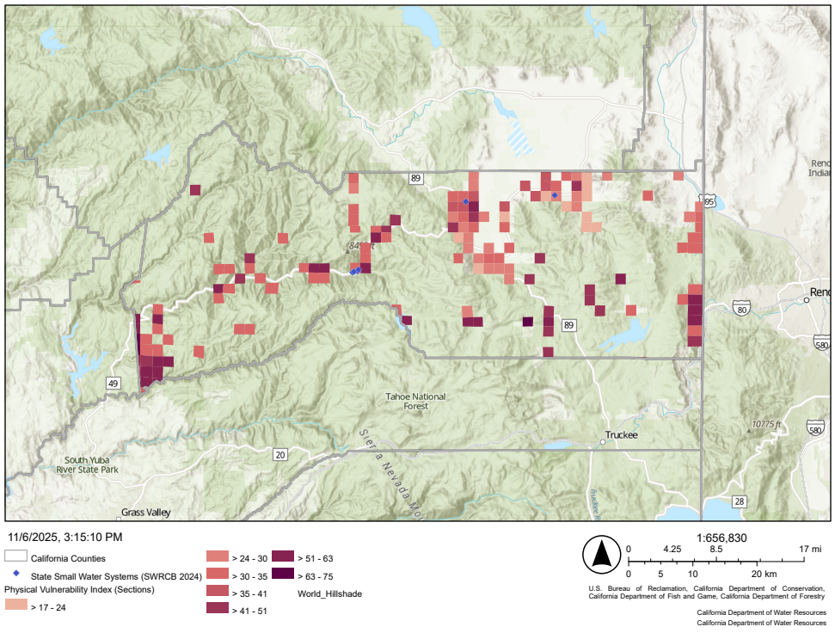
Source: Water Shortage Vulnerability Explorer Tool, https://arcg.is/1LCKGO, Accessed: 11/2025
Figure ‎3-2. Physical Vulnerability to Drought and Water Supply Shortage in Sierra County
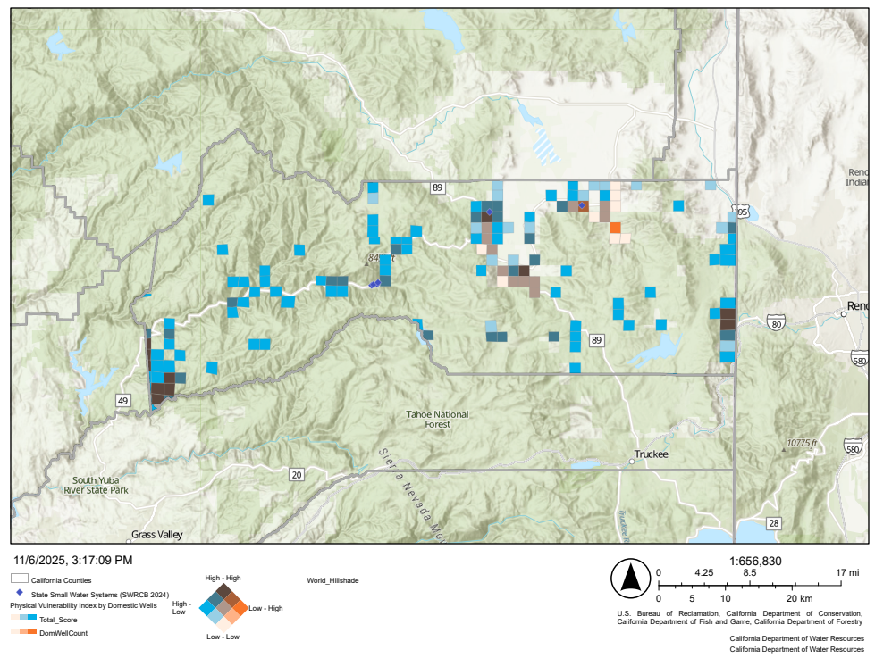
Source: Water Shortage Vulnerability Explorer Tool, https://arcg.is/1LCKGO, Accessed: 11/2025
Figure ‎3-3. Intersection of Physical Vulnerability and Density of Domestic Wells and State Small Water Systems in Sierra County
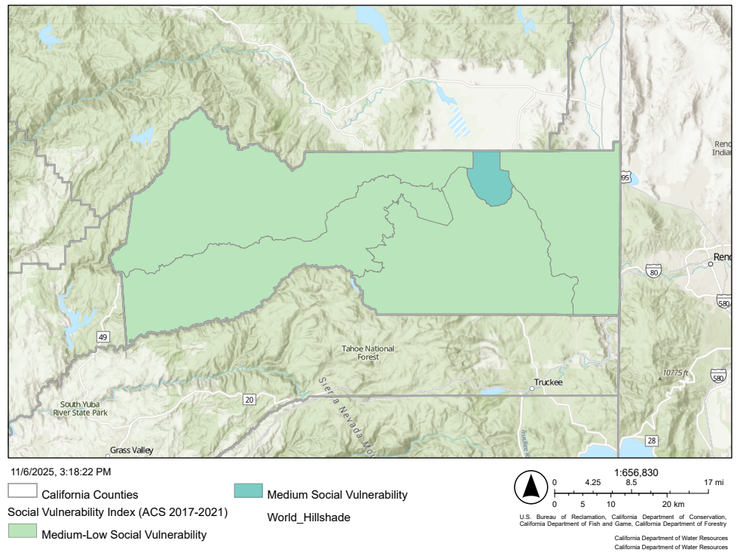
Source: Water Shortage Vulnerability Explorer Tool, https://arcg.is/1LCKGO, Accessed: 11/2025
Figure ‎3-4. Social Vulnerability Scores by Census Block Group in Sierra County

Physical Vulnerability Indicators
The risk assessment summarizes where water shortages associated with domestic wells and SSWSs are most likely to occur. This section provides a detailed description of the factors driving water shortage risk. Identifying and characterizing these drivers of physical vulnerability helps the County and the Task Force develop effective short-term actions and long-term strategies, along with their associated implementation.
Within the County, the primary indicators driving physical vulnerability are geology, domestic well density in a fractured rock basin, and wildfire risk. Details on these three indicators are included below, and information on all physical vulnerability indicators is summarized in Table 3-3.
An underlying driver of water shortage vulnerability in the County is the large area that lies within a fractured rock basin, with the geology indicator showing the fractured rock basin depicted in Figure 3-5. Water availability in fractured rock areas is more challenging to track and manage. There are several areas in the County with a high density of domestic wells in a fractured rock basin (red cells in Figure 3-6), including Pike, Verdi, and Calpine. Within these areas, competing demands from multiple domestic wells increase the risk of water shortages during droughts or other conditions that stress the water supply.
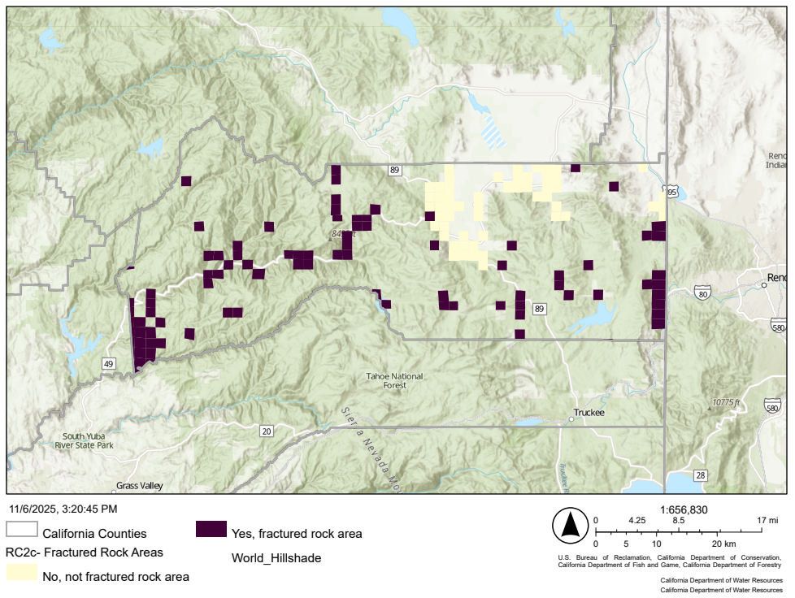
Source: Water Shortage Vulnerability Explorer Tool, https://arcg.is/1LCKGO, Accessed: 11/2025
Figure ‎3-5. Geology Indicator Showing Fractured Rock Area in Sierra County

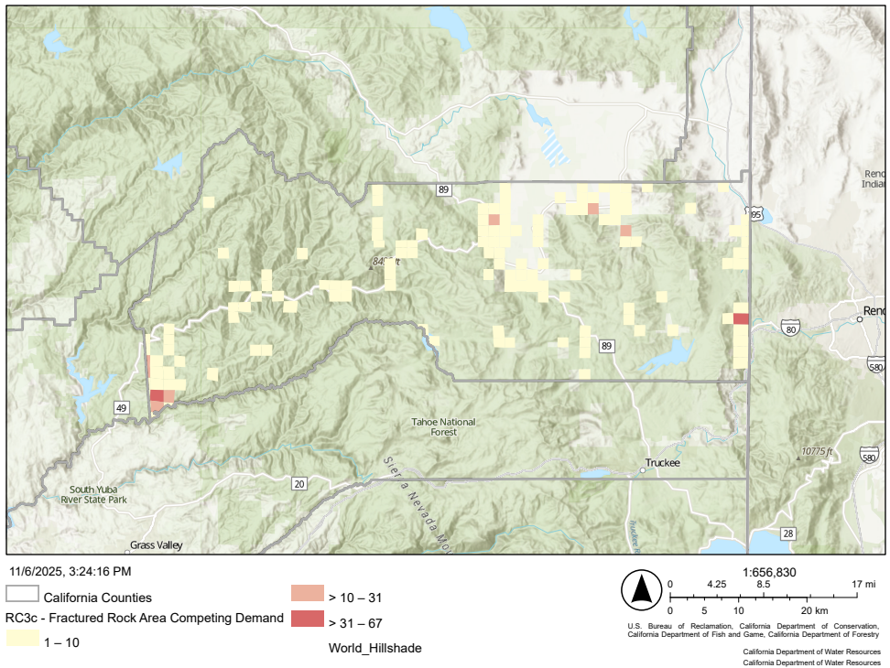
Source: Water Shortage Vulnerability Explorer Tool, https://arcg.is/1LCKGO, Accessed: 11/2025
Figure ‎3-6. Domestic Well Density in Fractured Rock Areas Indicator in Sierra County
Another indicator driving water supply shortage in the County is the exposure to wildfire hazards, as shown in Figure 3-7. Wildfires damage or destroy natural infrastructure such as watersheds and natural reaches, as well as built infrastructure such as pipelines and reservoirs. This increases a community’s vulnerability to water shortages due to the damage and/or the impacts on water supplies. Areas with high or very high wildfire hazard ratings also overlap with several of the areas of highest density of domestic wells within fractured rock basins (Calfire 2025 and DWR 2024b). The overlap of these indicators is the major driver of water shortage vulnerability to domestic wells and SSWSs within the County. A summary of all physical vulnerability indicators is provided in Table 3-3.

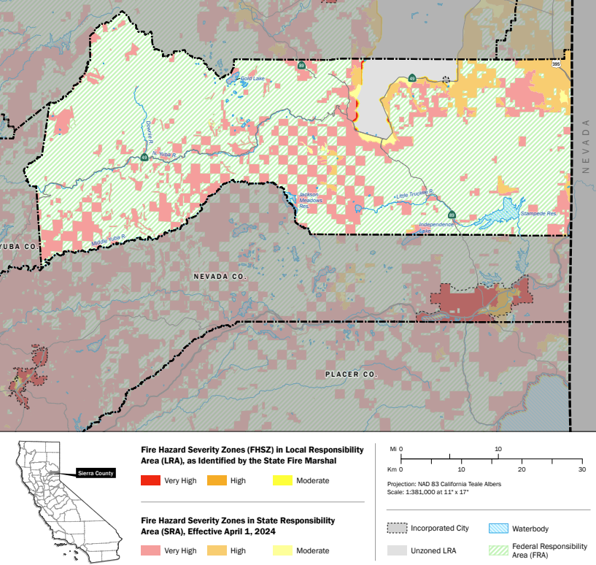
Source: Local Responsibility Area Fire Hazard Severity Zones, https://www.sierracounty.ca.gov/DocumentCenter/View/10920/FHSZ_County_LRA_11x17_SierraCo?bidId=, Accessed: 10/2025
Figure ‎3-7. Wildfire Hazard Potential in Sierra County (Adapted from Calfire 2025)

Table 3-3. Summary of Observed Conditions for Physical Vulnerability Indicators in Sierra County
Physical Vulnerability Indicator | Observed Conditions
Climate Change
Temperature Shift | The projected change in the maximum temperature by midcentury shows a 2.9 °F (southern portion of the County, close to the water bodies) to 3.5 °F (northern portion) increase in average temperature throughout the County. Increased temperatures could increase water supply demands from users, evapotranspiration, and others, thereby increasing vulnerability to drought and/or water shortage impacts.
Wildfire Risk | Projections indicate moderate to severe increases in wildfire risk throughout the County by 2035–2064. The largest increase is projected for the western portion of the County, while the eastern region is anticipated to be the least affected. The projected increase in wildfire frequency and severity poses inherent risks that heighten the vulnerability of water sources.
Saltwater Intrusion Projection | Water in the County is not tidally influenced and is not anticipated to experience saltwater intrusion.
Current Environmental Conditions and Events
2024 Precipitation | Precipitation in Water Year 2024 was below the historic average in the southeastern portion of the County and in certain parts of the Sierra Valley Groundwater Basin.
Multiple Dry Years | Data show that the County has experienced 2 dry years over the last 5 years. A higher number of recent dry years may increase the physical vulnerability of water supply conditions due to resource depletion and prolonged periods without sufficient water.
Fractured Rock Areas | Fractured rock is present across the entire County with the exception of the Mohawk Valley, Sierra Valley, and Long Valley Groundwater Basins in the north-central and east-central regions. Water availability in fractured rock areas is more difficult to monitor and, therefore, more uncertain for those relying on it as a source of water. Areas with fractured rock are considered in the County DRP due to their high susceptibility to drought impacts.
Current Wildfire Risk | Locations in County with domestic wells are classified as very high or high wildfire hazard risk, with most areas being classified as very high.
Water quality index | This index shows that the potential risk of future groundwater quality issues is high or medium across the Calpine area, primarily due to arsenic. Note that this does not mean there are current water quality issues or that there will be future groundwater issues.
Subsidence presence: Record of subsidence | No subsidence has been reported in the County. Higher subsidence creates higher vulnerability conditions.
Critically overdrafted groundwater basin | No groundwater basins in the County are considered critically overdrafted.
Declining groundwater levels | Groundwater level decline has been observed within portions of the Sierra Valley Groundwater Basin. Consistently declining groundwater levels cause several interconnected challenges and consequences, exacerbating the vulnerability of the groundwater system.
Irrigated agriculture: Presence of irrigated agriculture | There is minimal farming in the County, with all irrigated agriculture located in the Sierra Valley Basin. Presence of agricultural activities could indicate competing demand for groundwater suppliers, as well as water quality concerns, both of which could create higher vulnerability for domestic wells and SSWSs, especially during a drought or water shortage event.
Infrastructure Susceptibility
Alluvial Basin only: Dry well susceptibility—Estimated likelihood of domestic well(s) running dry | This factor analyzes locations with many susceptible wells that may go dry if current groundwater trends in the County continue. Data indicate a low overall likelihood of dry well susceptibility, including the medium groundwater basin in the northeastern portion of the County.
Fractured Rock Area only: High density of domestic wells | A higher density of domestic wells within a single square mile in a fractured rock area tends to increase susceptibility to outages and competing demands, especially during a dry period. The domestic well data in the County indicate low competing demand in fractured rock areas, except for the Pike and Verdi communities.
Record of Shortage
Reported household outages on domestic wells—Presence of domestic wells running dry | Areas that have already experienced outages are more likely to experience similar conditions during future dry years, due to combinations of aquifer sensitivity/fluctuations and shallow wells. No household outages have been reported in the County.

Risk Assessment Findings
The areas within the County with domestic wells and/or SSWSs that are vulnerable to a water supply shortages, the indicators of those physical vulnerabilities, and the corresponding total social vulnerability scores are presented in Table 3-4 and shown in Figure 3-8. These areas and vulnerabilities were used by the County and the Task Force to develop short-term actions and long-term strategies for addressing water shortage in domestic wells and SSWSs across the County.
Table 3-4. Summary of Risk Assessment Findings in Sierra County
Area with Water Shortage Vulnerability and Domestic Wells/SSWSs | Physical Vulnerability Indicators | Social Vulnerability Score | Location in Figure 3-8
Communities in Fractured Rock Basins (Pike, Calpine, and Verdi) | - Dry well susceptibility in fractured rock area  - Multiple dry years within the past 5 years  - Wildfire Hazard  - Water quality index | Medium-Low | A
Areas within the Sierra Valley Basin near Loyalton and Sierraville | - Percent land as irrigated agricultural  - Water quality index | Medium | B
Domestic wells, SSWSs, and small spring systems along North Yuba River | - Dry well susceptibility in fractured rock area  - Multiple dry years within the past 5 years  - Wildfire Hazard | Medium-Low | C
Isolated Domestic Wells in Fractured Rock Areas Across the County | - Dry well susceptibility in fractured rock area  - Multiple dry years within the past 5 years  - Wildfire Hazard | Medium-Low | Not Shown

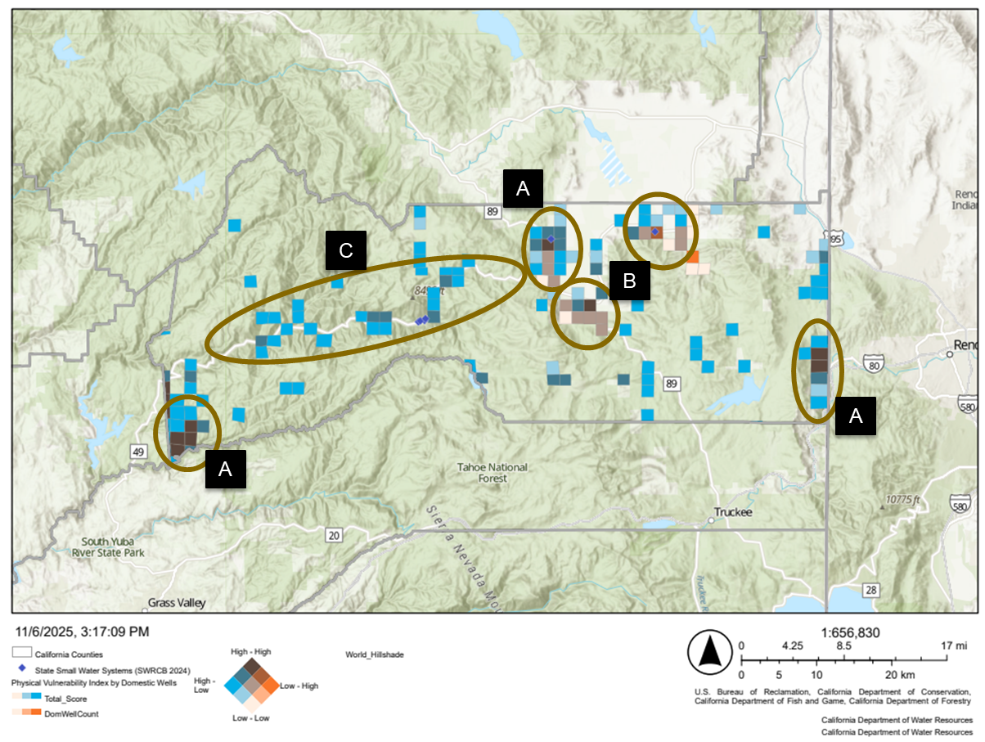
Figure ‎3-8. Summary of Risk Assessment Findings Showing Areas with Water Shortage Vulnerability and Domestic Wells in Sierra County

Risk Assessment Gaps
Understanding gaps in the risk assessment (1) helps identify physical and social vulnerabilities that may exist but are not effectively captured using the methodology applied and data available, (2) focuses future efforts to improve future risk assessments, and (3) allows communities to develop long-term, continuous monitoring and improvement plans. This proactive approach helps build resilience over time. The risk assessment gaps described below were identified by the County, the Task Force, and other stakeholders during the development of the County DRP.
- Domestic Well and SSWS Data: County staff noted that the domestic wells reported online are incomplete. Online databases could be updated using digitized County forms and local knowledge. County staff have indicated the need to digitize physical forms.
- Other Water Systems: Task Force members noted that a more comprehensive risk assessment would include (1) spring-fed systems, which are thought to be at a higher risk of a water supply shortage than domestic wells, and (2) other systems that are currently not regulated besides domestic wells and spring-fed systems.
- County-specific Geographic Groupings: Task Force members proposed a separate regional breakdown based on local community identities (instead of the Census Block Groups used in the WSVE Tool for social vulnerability). Task Force members noted that data could be more applicable if updated to reflect these regions.

Short-Term Response Actions
The risk assessment presented in Chapter 3 indicated that domestic wells and SSWSs in fractured rock areas and the Sierra Valley Basin may be susceptible to water shortages, particularly due to extended droughts. Based on the outcomes of that assessment, the County DRP identified STRAs to include in this County DRP to help address the effects of water shortage emergencies that could occur in the vulnerable regions of the County. The identified STRAs are not exhaustive and may be modified in the future. In the context of this County DRP, STRAs are defined as actions implemented in advance of, and during, water shortage emergencies caused by drought and water shortage events, often addressing immediate and basic public safety needs.
This section describes the STRAs included in the County DRP and the Drought and Water Shortage Emergency Response Process developed as part of the County DRP to assist with implementing STRAs.

Legislative Direction
SB 552 requires that each county develop a drought and water shortage plan that includes proposed interim solutions for SSWSs and domestic wells, per CWC Section 10609.70 (boldface added for emphasis as related to STRAs and this section of the County DRP):
(b) A county shall develop a plan that includes potential drought and water shortage risk and proposed interim and long-term solutions for state small water systems and domestic wells within the county’s jurisdiction. The plan may be a stand-alone document or may be included as an element in an existing county plan, such as a local hazard mitigation plan, emergency operations plan, climate action plan, or general plan. A county shall consult with its drought task force or alternative coordinating process as established by this section in developing its plan. A county shall consider, at a minimum, all of the following in its plan:
(1) Consolidations for existing water systems and domestic wells.
(2) Domestic well drinking water mitigation programs.
(3) Provision of emergency and interim drinking water solutions.
(4) An analysis of the steps necessary to implement the plan.
(5) An analysis of local, state, and federal funding sources available to implement the plan

Short-Term Response Actions Included in the Sierra County Drought Resilience Plan
STRAs included in the County DRP are summarized in Table 4-1 and described in this section. Most of these STRAs provide emergency and interim drinking water supplies via bulk water delivery or with packaged or bottled water. A process for STRA activation is presented in Section 4.4. Future efforts to address STRA implementation challenges and develop new STRAs are described in Section 6.2.2.
Table 4-1. List of Short-Term Response Actions Included in Sierra County Drought Resilience Plan
ID | STRA Type | STRA Name | STRA Description | Responsible Entity | Supporting Entities
STRA 01 | Emergency And Interim Drinking Water Supplies | Packaged and Bottled Water Supplies | County staff could acquire and distribute packaged or bottled water to domestic well and SSWS users during a water shortage emergency. | OES | Building and Planning
STRA 02 | Emergency And Interim Drinking Water Supplies | Temporary Point-of-Use Treatment for Bacterial Water Quality Issues | County staff could acquire and deploy temporary point-of-use treatment for SSWSs under a boil-water notice due to a bacterial water quality issue. | Environmental Health | OES
STRA 03 | Emergency And Interim Drinking Water Supplies | Dedicated Water Filling Stations | County staff could provide guidance on how to share water supplies safely. In the future, County staff could develop a network of emergency potable water supply stations/suppliers in the event of a water shortage emergency. | OES | Building and Planning,  Environmental Health, Local Water Providers
STRA 04 | Permit Streamlining and Coordination | Expedited New or Replacement Well Approval During Water Shortage | County staff could, within the County’s jurisdiction, prepare and implement expedited permit authorization for the construction of replacement wells in the event of a water shortage emergency. | Building and Planning | Environmental Health
Key:
Building and Planning = Sierra County Department of Building and Planning
County staff = Sierra County staff
Environmental Health = Sierra County Department of Environmental Health
OES = Sierra County Office of Emergency Services
STRA = Short-Term Response Action
SSWS = State Small Water Systems

Emergency and Interim Drinking Water Supplies
Emergency and interim drinking water supplies involve providing temporary water supplies until longer-term water supplies are secured or the water shortage emergency ends. Emergency and interim drinking water supplies are used during water shortage emergencies to meet basic health and safety needs.

Packaged or Bottled Water (STRA 01)
The County could provide packaged or bottled water (i.e., 1- to 5-gallon jugs and individual bottled waters) to affected domestic well and SSWS users during a water shortage emergency. Packaged or bottled water delivery is included as a STRA in this County DRP as STRA 01.
Packaged or bottled water would be sourced from local vendors. The California Department of Public Health’s Food and Drug Branch maintains a list of approved commercial bottled water vendors in the State. In the event of a State or federal disaster declaration, the County would coordinate with those entities to acquire packaged or bottled water and cost-sharing.
County OES is the lead entity for this STRA, with support from County Building and Planning. Packaged or bottled water would be distributed to affected domestic well or SSWS users following the process described in Section 4.4.2. Locations, operating hours, and other information regarding packaged or bottled water would be communicated using the process described in Section 4.4.2.

Temporary Point-of-Use Treatment for Bacterial Water Quality Issues (STRA 02)
The County identified installing temporary water treatment systems at SSWSs under a boil notice due to bacterial water quality issues as a future STRA. The use of spring-fed surface water can result in a water supply that does not meet bacterial water quality standards, and the affected SSWS is then subject to a boil-water notice. A temporary point-of-use treatment system would help ensure a safe water supply until a permanent solution is developed, such as consolidating systems or treating source water.
At the time of this County DRP, the County does not have the resources for such treatment systems. To make this STRA available for emergency or interim use, County staff would require funding to purchase point-of-use treatment systems, assistance with installation, and assistance with training spring-fed and SSWS users on how to operate them. The County would remain informed of applications for these systems and opportunities to assist in acquiring them. County OES is the lead for this STRA, which is included in this County DRP as STRA 02.

Dedicated Water Filling Stations (STRA 03)
During a water shortage emergency, domestic well or SSWS users could take water from dedicated water filling stations owned and operated by large water purveyors. These water filling stations are at established locations that would provide potable water to the affected users. Domestic well or SSWS users would need to provide their own water storage containers. County staff have observed the ad hoc use of water filling stations by neighbors sharing water with neighbors experiencing water shortages. Dedicated water filling stations are included in this County DRP as STRA 03.
County staff could develop and communicate guidelines for responsible ad hoc water sharing among neighbors. This would include informational materials on safe equipment to use, notifying the County for further assistance, and establishing limitations on the amount of water sharing allowed above, for which a license must be acquired to prevent misuse. In the future, the County could develop water filling stations to ensure the water provided is potable. These would be located within the service areas of larger providers at public buildings. Specific locations would be identified and operational logistics established as the County has resources.
Pacific Gas and Electric Company (PG&E) sometimes conducts Public Safety Power Shutoffs (PSPS) during hot, windy conditions to reduce the risk of wildfires starting from transmission lines. This shuts off power to the western portion of the County, which PG&E serves. During these PSPS, PG&E sets up community resource centers that include water supplies. The County would assist PG&E in communicating with domestic well and SSWS communities to ensure they are aware of these community resource centers.
County OES is the lead entity for this STRA, with support from County Building and Planning and County Environmental Health.

Permit Streamlining and Coordination (STRA 04)
As drought or water shortage conditions worsen and the production or quality of water at domestic wells or SSWSs declines, well owners may be able to install a new well or rehabilitate an existing one to ensure continued water supply reliability. Within the County’s authority, streamlining the permitting process for activities such as new well construction or existing well rehabilitation for domestic well or SSWS users would provide relief during an ongoing water shortage. This streamlining process does not relax permitting criteria related to water supply, such as proximity to other wells or water quality. Failing to consider water supply criteria appropriately could worsen a water supply shortage for other groundwater users or exacerbate an ongoing water shortage. Permit streamlining and coordination are included in this County DRP as STRA 04.
County staff have already implemented a streamlined well permitting process during water shortage emergencies and can usually approve new or rehabilitated well permits within a few days of submission. Permits within the Sierra Valley Groundwater Basin need to be further approved by the SVGMD, which can add time to the approval process. County staff would coordinate with the SVGMD on methods to streamline their approvals during a water shortage condition.
County Building and Planning is the lead entity for this STRA, with support from County Environmental Health.

Pre-Negotiated Contracts and Mutual Aid Agreements
Efficient implementation of STRAs requires coordination and cooperation with other entities beyond those within the County government. These can include pre-negotiated contracts and mutual aid agreements.
The acquisition of materials to implement this County DRP may be subject to local and State policies and regulations that govern their purchase. In the event of an emergency, counties can acquire materials necessary for the protection of public health, welfare, or safety via existing emergency procurement policies that are faster than traditional procurement. Exercise of this authority requires declaration of a local emergency and is time-limited, obligating counties to follow traditional procurement practices at the earliest practicable opportunity.
The County may seek to establish pre-negotiated contracts and other related agreements for STRA 01, STRA 02, STRA 03, and other STRAs as identified that can be exercised during a recognized water shortage event. This would allow the County to act quickly and maintain consistent resources during emergencies and interim water shortage events. Such pre-negotiated contracts may involve private companies or other local public agencies such as public water systems to secure needed resources. The establishment, renewal, and ongoing management of these pre-negotiated contracts will comply with traditional procurement practices as required by local and State policies, except when emergency procurement authorities are temporarily invoked during a declared emergency.
A mutual aid agreement is an arrangement established before an emergency through which another entity (or entities) provides personnel, equipment, materials, and/or associated services during an emergency. A mutual aid agreement clearly describes how the involved entities would engage with the County and each other during a water shortage emergency, along with their roles and responsibilities.
Mutual aid agreements recommended for efficient activation of STRAs are outlined in Table 4-2, including the entities that should have a mutual aid agreement, the nature of the mutual aid, and the status of any agreement as of November 2025.
Table 4-2. Pre-Negotiated Contracts and Mutual Aid Agreements Recommended for Activation of Short-Term Response Actions Included in the Sierra County Drought Resilience Plan (as of November 2025)
STRA | Contract or Mutual Aid Agreement Need | Lead | Status
STRA 01: Packaged and Bottled Water Supplies | County needs to procure pre-negotiated contracts for packaged and bottled water vendors. | County OES | Pending
STRA 03: Dedicated Water Filling Stations | County needs to develop mutual aid agreements with water providers to use as dedicated water filling stations. | County OES | Pending

Drought and Water Shortage Emergency Response Process
The Drought and Water Shortage Emergency Response Process describes (1) how County staff could evaluate drought and water shortage conditions in the County and declare a water shortage, and (2) its Emergency and Interim Drinking Water Distribution (EIDWD) Plan to activate emergency and interim drinking water supplies and communicate with affected domestic well and SSWS communities.

Drought or Water Shortage Triggers
Declaring a drought or water shortage is important as it communicates a potential or ongoing emergency, activates mutual aid agreements, and is the first step in accessing State and federal resources that may be available to assist the County in implementing STRAs.
This DRP outlines a process for classifying water shortage stages, as detailed in Appendix B. This process uses indicators of water supply with defined criteria that categorize the County into one of three water shortage stages: information, alert, and response, as described below.
- In the Water Shortage Information Stage, there is no major drought or potential for water shortage. In this stage, County staff completes its County DRP adaptive management planning as described in Section 6.2.
- In the Water Shortage Alert Stage, drought or the potential for water shortage exists, but there is no active water shortage emergency. In this stage, County staff increases communication and outreach activities and initiates coordination with other entities. County staff may consider recommending to the Task Force and/or the County Board of Supervisors the activation of the County's water conservation policy (Sierra County 2022).
- If a water shortage emergency is imminent or actively occurring, the County is in the Water Shortage Emergency Response Stage. In this stage, County staff, in coordination with the Task Force and County Board of Supervisors, would declare a water shortage emergency and activate the EIDWD Plan described in Section 4.5.2.
If a State drought or water shortage emergency declaration includes areas within the County, the County would go into the Water Shortage Emergency Response Stage and activate the EIDWD Plan described in Section 4.4.2. In the event of a federal disaster declaration, County staff would evaluate whether or not the disaster would require emergency and interim drinking water supplies. If the disaster would require such supplies, County staff would activate the EIDWD Plan. State and/or federal disaster declarations may make additional resources available to provide emergency and interim drinking water supplies. County staff would evaluate how these declarations may influence the implementation of the STRAs identified in this County DRP and the activation of the EIDWD Plan.

Emergency and Interim Drinking Water Distribution Plan
The EIDWD Plan outlines the process County staff could follow when distributing emergency and interim drinking water supplies to affected domestic well and SSWS communities. Table 4-3 shows the process County staff could follow in the event that distribution of emergency or interim drinking water supplies is required due to a short-term water shortage. These activities are anticipated for events lasting up to four weeks. Unless otherwise noted, implementation of these activities are subject to declaration of an emergency consistent with the County DRP or by direction of the County Board of Supervisors.
Table 4-3. Emergency and Interim Drinking Water Distribution Plan Summary
EIDWD Plan Component | Description
Lead Agency | County OES leads the EIDWD Plan in coordination with County Environmental Health.
Activation | Activation of the EIDWD Plan is subject to recommendation by County Environmental Health to County OES. Activation is informed by an assessment conducted by County Environmental Health that includes:  - Trigger or cause of water shortage emergency. See Section 4.4.2 for drought and water shortage triggers to be considered in the assessment  - Affected geographic area and demographics of the affected population  - Emergency and interim water supply type(s). See Table 4-1 for options  - Estimated duration of need  County OES, following review of the assessment, may authorize activation administratively, through the County Board of Supervisors, or other applicable authorities.
Notification | County OES will serve as the lead agency managing notification to the affected community on how and where to get emergency water supplies. The notification method may vary depending on the cause of the water shortage emergency (climate influenced, wildfire, power interruption, etc.) Anticipated notification methods include:  - Agency website: https://www.sierracounty.ca.gov/  - Email  - U.S. Mail  - Broadcast media (radio/television)  - Door hangers, fliers, information kiosks  - Public outreach meetings, and other existing meetings  - Hotline (311, other)  Conduct of notifications may include coordination/collaboration with other partner agencies and organizations, such as:  - Neighborhood Associations  - Nonprofit Organizations  - Schools, Churches, and Community Groups  Depending on the demographics of the affected community, information, materials, and other notifications may be required for non-English speaking communities. County OES will determine whether bilingual services are needed in support of water distribution activities.
Information Collection | The County OES will collect specific information to support applicable cost recovery and to inform future EIDWD efforts. Such data collection would not include personal information, but would generally include:  - Number of people served by emergency supply, including age and household income  - General geographic location of household  - Occupancy status (homeowner or tenant)  - The duration for which emergency supplies would maintain water needs  - Distance traveled to receive emergency supplies and mode of transportation  - Known condition of well and prior experiences with water supply shortages  - Others as identified as needed
EIDWD Plan = Emergency and Interim Drinking Water Distribution Plan
County OES = County Office of Emergency Services

Long-Term Mitigation Strategies and Actions
Findings revealed through the risk assessment presented in Chapter 3 show localized and regional water supply concerns, including the density of domestic wells in fractured rock areas, water quality risks, wildfire, and multi-year droughts. While risks that impact the basic public health and safety of residents can be addressed through STRAs, Long-Term Mitigation Strategies and Actions (LTMSA) mitigate and potentially prevent the conditions that lead to water shortage emergencies. This County DRP identified 18 LTMSAs, organized into four categories: drinking water well mitigation programs, system consolidation, regional water infrastructure investment, and data gaps. These LTMSAs are not exhaustive and may be modified in the future.
In the context of this County DRP, LTMSAs serve to reduce drought and water shortage vulnerabilities for domestic well and SSWS communities. When implemented, LTMSAs can reduce the extent and cost of emergency response actions, but cannot eliminate the need for them.

Legislative Direction
SB 552 requires that each county develop a drought and water shortage plan that covers long-term solutions for SSWSs and domestic wells, per CWC Section 10609.70 (boldface added for emphasis as related to LTMSAs and this section of the County DRP):
(b) A county shall develop a plan that includes potential drought and water shortage risk and proposed interim and long-term solutions for state small water systems and domestic wells within the county’s jurisdiction. The plan may be a stand-alone document or may be included as an element in an existing county plan, such as a local hazard mitigation plan, emergency operations plan, climate action plan, or general plan. A county shall consult with its drought task force or alternative coordinating process as established by this section in developing its plan. A county shall consider, at a minimum, all of the following in its plan:
(1) Consolidations for existing water systems and domestic wells.
(2) Domestic well drinking water mitigation programs.
(3) Provision of emergency and interim drinking water solutions.
(4) An analysis of the steps necessary to implement the plan.
(5) An analysis of local, state, and federal funding sources available to implement the plan

Long-Term Mitigation Strategies and Actions Included in the Sierra County Drought Resilience Plan
LTMSAs included in the County DRP are summarized in Table 5-1Table 5-1. LTMSAs related to drinking water well mitigation programs are described in Section 5.3; the one system consolidation opportunity within the County is described in Section 5.4. The ability of regional water planning to help address domestic well and SSWS vulnerabilities is detailed in Section 5.5. LTMSAs that address data gaps are discussed in Section 5.6. Future efforts related to LTMSA implementation and challenges are described in Section 6.2. The LTMSAs shown in this table may be updated or replaced as part of future County DRP updates.
Table 5-1. List of Long-Term Mitigation Strategies and Actions Included in Sierra County Drought Resilience Plan
ID | LTMSA Category and Type | LTMSA Name | LTMSA Description | Responsible Entity | Supporting Entities
LTMSA 01 | Drinking Water Well Mitigation Programs: Communication and Outreach | Domestic Well and SSWS Resource Website | County staff could create, review, and maintain a website with relevant information (contacts, permits, data, etc.) for domestic well and SSWS communities. | OES | Building and Planning, Environmental Health
LTMSA 02 | Drinking Water Well Mitigation Programs: Communication and Outreach | Maintain Network of Vendors and County Contacts | County staff could create and maintain a contact list of County departments, well drillers, and laboratories to be shared with domestic well and SSWS communities. The contact list would be posted on the County website. The list would include a disclaimer stating that it does not serve as a recommendation or endorsement. | Building and Planning | Environmental Health, OES, Public Works
LTMSA 03 | Drinking Water Well Mitigation Programs: Communication and Outreach | Supply Interruption Notification for Public Safety Power Shutoffs | County staff, in coordination and collaboration with power utilities, could establish a distribution list of domestic well and SSWS users to contact in advance of public safety power shutoffs. When a power interruption is anticipated, County staff would coordinate with these entities on initial notification. | OES | Environmental Health
LTMSA 04 | Drinking Water Well Mitigation Programs: Water Shortage Prevention | Regional Groundwater Level Monitoring and Communication | County staff could update website with groundwater level monitoring information, including characterizing monitoring data from SVGMD. | Environmental Health | SVGMD
LTMSA 05 | Drinking Water Well Mitigation Programs: Water Shortage Prevention | Assistance with Domestic Well Monitoring | The County currently does not have funding to assist with domestic well monitoring beyond providing contact information for well samplers. In the future, the County could, in coordination with SVGMD, provide financial and technical assistance to domestic well and SSWS communities for collecting depth-to-water information from their wells. | Environmental Health | SVGMD
LTMSA 06 | Drinking Water Well Mitigation Programs: Water Shortage Prevention | Water Quality Outreach for Domestic Wells and SSWSs | County staff could update website with groundwater quality information. This includes characterizing water quality data from the County and SVGMD and linking to informational brochures from other entities. | Environmental Health | SVGMD
LTMSA 07 | Drinking Water Well Mitigation Programs: Water Shortage Prevention | Point-of-Use Water Treatment Installation | County staff could conduct outreach to relevant domestic well and SSWS communities on point-of-use water treatment options (e.g., under-sink reverse osmosis, whole-house filter packs, etc.) to address bacterial and arsenic water quality issues. With additional resources the County could provide extended financial and/or technical assistance. | Environmental Health | California State Water Resources Control Board
LTMSA 08 | Drinking Water Well Mitigation Programs: Water Shortage Prevention | SSWS Vulnerabilities Assurance | County staff will continue to require will-serve letters for new developments to ensure domestic wells and SSWS have the capacity to serve proposed customer additions and/or connections. | Environmental Health | Building and Planning, State Water Board
LTMSA 09 | Drinking Water Well Mitigation Programs: Water Shortage Prevention | Aging Infrastructure Assessment | The County does not have funding to complete an aging infrastructure assessment and replace aging infrastructure. County staff could review opportunities to leverage funding for consolidation and FEMA funding to replace aging infrastructure that supports fire suppression. | Building and Planning | Environmental Health, Public Works
LTMSA 10 | Drinking Water Well Mitigation Programs: Water Shortage Prevention | Grant application assistance to domestic wells and SSWS | County staff could include information on potential grants available for domestic well and SSWS communities on their website. | Building and Planning | Environmental Health, OES, Public Works
LTMSA 11 | Drinking Water Well Mitigation Programs: Water Shortage Prevention | Bulk Water Tank and/or Power Generator Installation | County staff could conduct outreach to domestic wells and SSWSs with resources for sizing and installing bulk water storage tanks and/or power generators at existing wells. With additional resources, the County could provide relevant financial and/or technical assistance. | Building and Planning | Environmental Health, OES, SVGMD
LTMSA 12 | Drinking Water Well Mitigation Program: Water Shortage Prevention when Permitting New or Replacement Wells | Well Permitting Considering Future Growth | County staff could consider future growth when permitting a new or replacement well. This would include reviewing development plans, SVGMP documents, or other information detailing future demands. | Building and Planning | SVGMD
LTMSA 13 | System Consolidation | Existing System Consolidation Opportunities – Sierra City Area | County staff will continue supporting SSWS communities and Sierra City Water Works in the pursuit of funding and additional resources for further development and implementation of the plan for physical consolidation. | Environmental Health | Building and Planning
LTMSA 14 | System Consolidation | Potential System Consolidation Opportunities | County staff could support consolidation efforts as identified by domestic well and SSWS communities and community water systems. This could include technical assistance, coordination, and, if funding is available, developing a system consolidation analysis. | Environmental Health | Building and Planning
LTMSA 15 | Regional Water Infrastructure Investment | Regional Planning Integration | County staff would participate in related regional planning efforts to provide the perspective of domestic well and SSWS communities. | Environmental Health | Building and Planning, OES
LTMSA 16 | Data Gaps | Evaluate and Update Well Completion Report Administrative Record | County staff could review the well completion report dataset and coordinate with DWR and domestic well owners (if necessary) to update and correct well completion data. | Environmental Health | Building and Planning
LTMSA 17 | Data Gaps | Dry Well Reporting and Abandonment | County staff could coordinate with DWR, SVGMD and other relevant entities to improve the accuracy of dry well reporting, including evaluation of County well completion reports to identify wells installed to supplement low-performing wells and noting abandoned wells. | Environmental Health | Building and Planning
LTMSA 18 | Data Gaps | Create Local Small System Classification and Monitoring for Communities with 2 to 4 Connections and those that Serve the Public | County staff could establish a Local Small System monitoring program by (1) evaluating well permits and well completion reports for domestic wells that serve 2 to 4 connections and/or serve the public, and (2) monitoring water quality consistent with how SSWSs are monitored. | Environmental Health | Building and Planning
Key:
Building and Planning = Sierra County Department of Building and Planning
County = Sierra County
County staff = Sierra County staff
DWR = California Department of Water Resources
Environmental Health = Sierra County Department of Environmental Health
FEMA = Federal Emergency Management Agency
LTMSA = Long-Term Mitigation Strategies and Actions
OES = Sierra County Office of Emergency Services
Public Works = Sierra County Department of Public Works
SSWS = State Small Water Systems
SVGMD = Sierra Valley Groundwater Management District
SVGMP = Sierra Valley Groundwater Management Plan

Drinking Water Well Mitigation Programs
This County DRP considers the utility of domestic water well mitigation (DWWM) programs within the County DRP as directed under CWC Section 10609.70 (b)(2). “DWWM program” describes actions that provide assistance to domestic well and SSWS communities with groundwater wells that are relatively shallower than those in the area or are located in specific areas where wells are at a higher risk of running dry more frequently. This section first identifies the DWWM program(s) within the County organized by Bulletin 118 groundwater basins and fractured rock areas. It then details the LTMSA components that are included in the DWWM programs. The DWWM programs and LTMSA components described herein are not exhaustive and may be modified in the future.
When identifying and defining DWWM programs, the County DRP considered the factors listed below:
- Domestic wells and SSWSs vulnerable to water supply shortages (see Chapter 3)
- If a DWWM program had already been defined as part of a GSP
- The SGMA priority for Bulletin 118 basins
- The occurrence of potentially shallow wells that could be at enhanced risk of drying up
- History of dry well reports and/or new well permits for replacement or deepened wells
Table 5-2 details the identified DWWM programs within the County.
Table 5-2. Drinking Water Well Mitigation Programs within the County
Location | Vulnerable Domestic Wells and SSWSs Included | DWWM Program Description
Sierra Valley Groundwater Basin | Areas within the Sierra Valley Basin near Loyalton and Sierraville (vulnerable area B in Section 3.5) | The Sierra Valley GSP does not include a DWWM program. Wells in this area were generally found not to be at risk of dry-up or water quality impacts and had a low occurrence of shallow wells relative to others in the area. The DWWM program for this area will focus on communication and outreach, as well as water shortage prevention.
Communities in Fractured Rock Basins | Domestic wells in Pike, Calpine, and Verdi, along the North Yuba River, and other isolated domestic wells (vulnerable areas A, C, and D in Section 3.5) | There has not been a systematic or concentrated history of well dry-ups within fractured rock areas in the County. The DWWM program for this area will focus on communication and outreach, as well as water shortage prevention.

Communication and Outreach (LTMSA 01, 02, 03)
Effective communication and outreach are essential components of drought resilience efforts, enabling timely information sharing and community engagement to support water shortage mitigation. These strategies aim to provide accessible resources to domestic well and SSWS communities, enabling them to improve the reliability of their water supply.

Domestic Well and SSWS Resource Website (LTMSA 01)
As part of this County DRP, the County established a website focused on domestic well and SSWS communities. County staff could update and maintain this website to enhance its content as part of other LTMSAs. This website would house a variety of relevant resources such as the County DRP, contact information, links to monitoring and water quality data, and characterization of water supply. OES would maintain the website with input from Environmental Health, Building and Planning, and Public Works. Technical content, such as sampling guidance, disinfection information, and well safety information would be reviewed by Environmental Health prior to inclusion on the website.

Establish Network of Vendors (LTMSA 02)
County staff have a list of well drillers and laboratories that provide water sampling and testing services. This list is available to domestic well and SSWS communities and would include a disclaimer stating that it does not serve as a recommendation or endorsement from the County. County staff could (1) continue to maintain this list with regular updates, (2) post this list on its website, and (3) remind domestic well and SSWS communities of this list during drought or other events that could cause water shortages. Building and Planning is lead for this LTMSA, with support from OES, Environmental Health, and Public Works.

Supply Interruption Notification for Public Safety Power Shutoffs (LTMSA 03)
Due to its heavily forested land and vulnerability to wildfires, there are times when power utilities in the County conduct PSPS to reduce the potential of wildfire ignition. A PSPS can sometimes last multiple days, which results in domestic well and SSWS communities being unable to pump water supplies. County staff could coordinate with these power utilities to ensure domestic well and SSWS communities are included in notifications. PG&E has a system in place for its service area in the western portion of the County and Liberty Utilities is setting up a notification system for the eastern portion of the County. While individuals need to sign up for notifications, County staff would conduct outreach to domestic well and SSWS communities prior to a PSPS using strategies such as social media posts, emails to distribution lists, and phone calls. County staff would also coordinate with these power utilities during initial notification. OES is the lead for this LTMSA.

Water Shortage Prevention (LTMSA 04, 05, 06, 07, 08, 09, 10, 11)
These actions and strategies address water supply vulnerabilities by improving the understanding of groundwater conditions and enhancing the resilience of domestic well and SSWS groundwater assets.

Regional Groundwater Level Monitoring and Communication (LTMSA 04)
County staff could coordinate with the SVGMD to communicate its groundwater level monitoring to domestic well and SSWS communities. This includes linking to updated SVGMD annual reporting on the County website and characterizing results specifically for domestic well and SSWS communities. SVGMD typically completes groundwater monitoring in October and April and develops an annual report by April 1 of each year. County staff would coordinate their website updates to include these SVGMD updates. Environmental Health is the lead for this LTMSA.

Assistance with Domestic Well Monitoring (LTMSA 05)
The vulnerable domestic wells within the County are in both the Sierra Valley Groundwater Basin and fractured rock areas. SVGMD monitors groundwater conditions within the Sierra Valley Groundwater Basin, but does not aid with sampling individual domestic wells. There is no existing groundwater monitoring program for domestic wells within fractured rock areas.
County staff could assist domestic well communities with monitoring their wells by providing contact information for laboratories that perform well sampling and testing, and who can assist with interpreting results. With additional resources, County staff could (1) coordinate with SVGMD to provide annual testing of domestic wells at no cost to the communities within the Sierra Valley Groundwater Basin, and (2) provide financial assistance to domestic well communities outside the Sierra Valley Groundwater Basin for an annual groundwater test. Data collected through these annual tests could then assist with broader groundwater monitoring. Environmental Health is the lead for this LTMSA.

Water Quality Outreach for Domestic Wells and SSWSs (LTMSA 06)
County staff could share water quality data with domestic well and SSWS communities on its website and update brochures related to known water quality issues. Communications with domestic well communities could focus on known water quality issues within their area and provide updates as new water quality data is collected. For domestic wells and SSWS within the Sierra Valley Groundwater Basin, County staff would coordinate with the SVGMD on collecting water quality data for presentation on the County website. Environmental Health is the lead for this LTMSA.

Point-of-Use Water Treatment Installation (LTMSA 07)
Domestic wells and SSWSs in the County are vulnerable to water supply interruptions due to water quality issues. Two current water quality issues are (1) bacterial contamination, primarily near Sierra City, and (2) arsenic levels near Calpine and Verdi. Assistance could include informational resources on point-of-use water treatment options and a list of vendors that install such systems. With additional resources, County staff could connect domestic well and SSWSs communities to grants or provide direct financial assistance to cover all or a portion of the costs of implementing these water treatment systems. Environmental Health is the lead of this LTMSA with support from the California State Water Resources Control Board (SWRCB).

State Small Water System Vulnerability Assurance (LTMSA 08)
The County has several spring-fed SSWSs concentrated in close proximity and using the same water supplies. County staff will continue to require will-serve letters for new developments prior to issuing a building permit in order to protect these spring-fed SSWSs and ensure available water supplies in accordance with design and operation standards outlined in CWC Title 22 Section 64400. Environmental Health participates in review of these requests and is the lead for this LTMSA.

Aging Infrastructure Assessment (LTMSA 09)
Many SSWSs in the County are old and have aging infrastructure issues. The owners and operators of these systems do not have the financial or technical capacity to properly evaluate these systems and identify solutions to address issues that improve water supply reliability. County staff, with available funding, could evaluate the infrastructure of these aging systems and identify options for them to improve their water supply reliability. Environmental Health is the lead for this LTMSA.

Grant Application Assistance (LTMSA 10)
State and federal grants may be available to domestic well and SSWS owners to help with a variety of items including technical training, new infrastructure, and studies. While the exact availability and resources covered by these grants vary, County staff could include links on its website to major funding organizations such as DWR and the Rural Community Assistance Partnership for domestic well and SSWS owners to check and track. Environmental Health is the lead for this LTMSA.

Bulk Water Tank and/or Power Generator Installation (LTMSA 11)
Bulk water tank installation at domestic wells and SSWSs could improve water supply reliability in areas commonly subjected to multi-day power outages due to PSPSs. In addition, power generators could also provide water supply reliability by enabling pumping even during a PSPS. In the near term, County staff might only provide outreach to these areas regarding the value of bulk water or power generator installation, and resources for installation. Building and Planning is the lead for this LTMSA with support from Environmental Health, County OES, and SVGMD. Cross-review of installation plans by this team could help to avoid risk of overdraft.

Water Shortage Prevention when Permitting New or Replacement Wells
(LTMSA 12)
Adding new wells, including those replacing an existing well, in areas where existing domestic wells and SSWSs have water supply vulnerabilities, can exacerbate those vulnerabilities. This LTMSA helps County staff consider how new wells may affect the water supply vulnerability.

Well Permitting Considering Future Growth (LTMSA 12)
When permitting new or replacement wells, evaluating these permits through the lens of future water use and land development can help improve overall water supply reliability. When evaluating new permits, County staff could include a review of other materials to determine if a deeper well than requested should be required, given the potential for increased demands on the same groundwater source. These other materials could include known development plans, SVGMD documents, and other planning documents that would include information on future water demand projections. Building and Planning is the lead for this LTMSA.

System Consolidation
System consolidation is the physical or managerial joining of two or more water systems. In the context of domestic wells and SSWSs, these systems can be consolidated with each other and/or a larger water system. System consolidation can improve water supply reliability by broadening water supply sources and/or the numbers of users. With more users in a singular system, operating and maintaining that system can be cost-effective compared to smaller or individual systems. This section identifies potential consolidation opportunities for domestic wells and SSWSs. The County DRP separates system consolidation opportunities into two categories: (1) existing (those that have already been identified and undergone at least an initial assessment), and (2) potential (those identified during development of this County DRP) based on proximity to community water system service area boundaries.

Existing Consolidation Opportunities (LTMSA 13)
Existing Efforts:
- Domestic Wells: There are currently no known consolidation efforts—past or ongoing—involving domestic wells.
- SSWSs: Within the County, SSWSs within the Sierra City area (Butte Mutual Water Company, Cemetery Water System, Maple Grove Mutual Water Company, and Tschopp Mutual Water Company) have been part of consolidation assessments including (1) a System Consolidation Plan completed in 2009, and (2) continued coordination amongst the SSWSs, Sierra City Water Works, and County Environmental Health. To date, system consolidation has not occurred due to insufficient funds.

Advancing Consolidation in the Sierra City Area (LTMSA 13)
This LTMSA involves completing a water system consolidation feasibility study, currently being prepared by consultants with State grant funding and anticipated for completion in spring 2026, with recommended alternatives for possible consolidation(s). County staff could continue supporting SSWS communities and Sierra City Water Works in pursuing funding and additional resources to further develop and implement the plan for physical consolidation. Building and Planning is the lead for this LTMSA.

Potential System Consolidation Opportunities (LTMSA 14)
There are system consolidation opportunities for domestic wells and SSWSs that are within the existing service area boundaries of a community water system. While a community water system is not required to provide water service to domestic well and SSWS communities, their proximity may increase the feasibility of system consolidation. There may be nearby water supply infrastructure from a community water system that could connect to domestic wells and SSWSs. Policy or institutional hurdles may be less onerous if domestic wells and SSWSs are in an existing service area.
The proximity of domestic wells and SSWSs to service areas of community water systems was evaluated to identify system consolidation opportunities. Table 5-4 summarizes areas where there may be opportunity for system consolidation. There may also be system consolidation opportunities outside the areas shown and described below. County staff could stay apprised of all potential opportunities as they arise.
In this LTMSA, County staff could support domestic well and SSWS communities and community water systems by assisting in the pursuit of funding and additional resources for exploration, development, and implementation of a plan for physical consolidation. Building and Planning is the lead for this LTMSA.
With additional resources, County staff could work with domestic well and SSWS communities and community water systems to further evaluate the opportunity for system consolidation and, if appropriate, develop a plan for system consolidation. This evaluation would include outreach to the domestic well and SSWS communities and community water systems within these areas to better understand the potential system consolidation opportunities (e.g., interest in and willingness to consolidate, water supply availability and water quality constraints, water delivery infrastructure [distance to, components and capacities], potential for funding and financing for a system consolidation study and infrastructure, points of contact, other considerations). County staff could lead the outreach effort or coordinate with those entities engaged in it.
Table 5-4. Areas with Opportunity for Domestic Wells and State Small Water Systems Consolidation
Area of System Consolidation Opportunity | Community Water Systems that Could be Involved in Consolidation | Consolidation Opportunity Description
Sierra City and Goodyears Bar Area Spring-Fed State Small Water Systems | Sierra City Water Works  Sierra Water Resources  Sierra Pines Resort  Loganville | There is a mixture of domestic wells, state small water systems, and individual spring-fed systems in these areas that could be consolidated with an existing system or consolidated into a new system.
Verdi Area Domestic Wells | Verdi, Nevada | There is a concentration of domestic wells in Verdi, California that are in close proximity to water utilities in Verdi, Nevada. These domestic wells could consolidate into that system.
Pike Area Domestic Wells | None | There is a high concentration of domestic wells in the Pike area that could consolidate into a new system.
Sierraville and Sattley Area Domestic Wells | Sierraville Public Utilities District | There are domestic wells near Sierraville, Sattley, and the Amodei Ranch area that could consolidate with the Sierraville Public Utilities District.

Regional Water Infrastructure Investment
Regional water infrastructure projects can enhance the water supply reliability of many communities, including domestic wells and SSWSs. The LTMSAs in this section describe how County staff could integrate into regional planning and regional water infrastructure to help enhance the water supply reliability of domestic well and SSWS communities. Additional information on the near-term integration into regional planning or water infrastructure is included in Section 6.3.

Regional Planning Integration (LTMSA 15)
Many regional and County planning efforts intersect with the County DRP. Coordination by County staff within these other regional and County planning efforts will help ensure these plans consider domestic wells and SSWSs. Table 5-5 details the relevant regional planning efforts, their current status, and their intersection with domestic wells and SSWSs. For LTMSA 15, County staff would participate when the planning effort is occurring and provide the perspective of domestic well and SSWS communities. Additional information on the timing and County roles/responsibilities for these efforts is presented in Section 6.3.
Table 5-5. Summary of Relevant Regional Planning Efforts
Planning Effort | Current Status | Intersection with Domestic Wells and SSWSs
County General Plan | Updated 1996, additional updates underway | The County General Plan covers areas with domestic wells and SSWSs.
Multi-Jurisdictional Local Hazard Mitigation Plan | Adopted December 2012; update in progress | Identifies and provides mitigation strategies for hazardous conditions such as drought, floods, storms, and wildland fires that have potential to impact the water supply reliability of domestic wells and SSWSs.
Sierra Valley Subbasin GSP | Adopted 2023 | The Sierra Valley subbasins covered in this plan include domestic wells and SSWSs.
Yuba County Integrated Regional Water Management Plan | Updated 2018 | The region covered by this plan includes domestic well users in southwestern Sierra County.
CABY Integrated Regional Water Management Plan | Updated 2021 | The region covered by this plan includes domestic well users and SSWSs in the western portion of the County.
Upper Feather River Watershed Integrated Regional Water Management Plan | Updated 2016 | The region covered by this plan includes domestic well users and SSWSs in the central part of the County, as well as the Sierra Valley Groundwater Basin area.
Lahontan Basin Integrated Regional Water Management Plan | Updated 2019 | The region covered by this plan includes domestic well users the northeastern part of the County.
Tahoe-Sierra Integrated Regional Water Management Plan | Updated 2019 | The region covered by this plan includes domestic well users in the southeastern part of the County.
Key:
CABY = Cosumnes, American, Bear, Yuba (counties)
County = Sierra County
SSWS = State Small Water Systems

Data Gaps (LTMSA 16, 17, 18)
This County DRP uses available data to support (1) evaluation of the vulnerability of domestic wells and SSWSs to water shortages, and (2) development and alignment of effective STRAs and LTMSAs. Access to new or more accurate/complete data would help improve this planning process in the future. This section details the LTMSAs identified by the County DRP that would provide new or improved data for use in future planning efforts.

Well Completion Reports (LTMSA 16)
DWR maintains an online public database of well completion reports submitted to the State by well drillers. This database includes type, location, well depth, year of installation, and address, among other information. The WSVE Tool uses this information to determine the locations of domestic wells, and this database was an important data source used when developing this County DRP. However, there are both gaps and limitations in these data. Some well locations may be incorrect—for example, they may display outside County boundaries or not be shown (because they are listed in the database as not being inside the County). Domestic wells that have been replaced or abandoned may still appear in the database. County staff could review the well completion report dataset and coordinate with DWR and domestic well owners (if necessary) to update and correct well completion data. Environmental Health is the lead for this LTMSA, with support by the Building and Planning Department.

Dry Well Reporting and Abandonment (LTMSA 17)
DWR established an online dry well reporting system for domestic well communities to report problems with their wells that impact their water supplies. County staff could monitor information submitted in this system to assist in identifying areas with current or past water shortages that can help inform the potential for future water shortages. However, not all domestic well and SSWS owners with a dry or impacted well have submitted a dry well report. Many times, they will drill a new deeper well without reporting the previously dry well. To address this data gap, County staff could update the well permit application so that the applicant must indicate if the new well is replacing a dry well.
County staff could review dry well reporting data (from DWR’s system and the well permit applications it receives) with well completion report data (LTMSA 15) to identify wells to be removed from the well completion report dataset that have been abandoned due to replacement or retirement. County staff could coordinate with DWR to update information in the well completion report. This coordinated review and update of well-related information could help develop a more comprehensive understanding of dry wells and water shortage issues in the County. Environmental Health is the lead for this LTMSA with support from the Building and Planning Department.

Create Local Small System Classification (LTMSA 18)
HSC Section 116275(n) and Section 10609.51(m) define a domestic well as having no more than four connections. However, to improve the water supply reliability of communities that have systems with two to four connections, County staff could create a monitoring program for these “local small systems.” Systems with two to four connections serve more population per system than single connections, and monitoring these systems could help improve their water supply reliability. Similarly, systems that serve the public but serve fewer than 25 people 60 or more days of the year, or serve 25 people fewer than 60 days a year, are currently unregulated and water quality and public health may benefit from monitoring. Systems with a single connection are not included due to the number of these systems in the County and the resources required to implement a program of this size. The program for local small systems would monitor water quality in a manner consistent with how County staff currently monitors SSWSs. County staff could evaluate well completion report data and any supplemental data to identify any local small systems within the County. The local small systems monitoring program could include maintaining a local small system database, regularly conducting water quality monitoring, and engaging in specialized outreach to local small system communities on system operations and maintenance. Environmental Health is the lead for this LTMSA.

Implementation Considerations
The STRAs and LTMSAs identified and described in Chapters 4 and 5 represent the range of in-progress and proposed activities. Implementation of these STRAs and LTMSAs often (1) falls under the authorities and jurisdictional responsibilities of separate County departments and other local and State public agencies, and (2) requires the involvement of other interested parties. To implement these STRAs and LTMSAs, and contribute to continued improvement of water supply reliability for domestic well and SSWS communities, this section describes the implementation steps designed to assist the County with:
- Ongoing water supply monitoring and interagency collaboration in support of implementation
- Outlining STRA and LTMSA implementation responsibility, status, and resource needs
- Identifying opportunities to align the County DRP with other County policy and County and regional planning documents
- Adaptive management
- Identifying funding opportunities

Legislative Direction
SB 552 requires the County to develop a drought and water shortage plan that analyzes the steps to implement the plan and the funding sources available to support that implementation, per CWC Section 10609.70 (boldface added for emphasis as related to plan implementation and this section of the County DRP):
(b) A county shall develop a plan that includes potential drought and water shortage risk and proposed interim and long-term solutions for state small water systems and domestic wells within the county’s jurisdiction. The plan may be a stand-alone document or may be included as an element in an existing county plan, such as a local hazard mitigation plan, emergency operations plan, climate action plan, or general plan. A county shall consult with its drought task force or alternative coordinating process as established by this section in developing its plan. A county shall consider, at a minimum, all of the following in its plan:
(1) Consolidations for existing water systems and domestic wells.
(2) Domestic well drinking water mitigation programs.
(3) Provision of emergency and interim drinking water solutions.
(4) An analysis of the steps necessary to implement the plan.
(5) An analysis of local, state, and federal funding sources available to implement the plan

Implementation Roadmap
This County DRP describes existing and proposed STRAs and LTMSAs that, when executed, help the County meet its objectives under CWC Section 10609.70 (b) (1), (b) (2), and (b) (3). Implementing these STRAs and LTMSAs would require resources and clear roles and responsibilities. The identified STRAs and LTMSAs include existing or new activities to be implemented under existing authorities and funding of County departments and those activities that are dependent on appropriation of funds from local, State, or federal resources. This section presents the implementation roadmap for this County DRP; identification of ongoing monitoring and collaboration with County staff; and conduct of management oversight, prioritization, and resource identification needs.

Monitoring and Collaboration
Supply monitoring and interagency collaboration support County DRP implementation by evaluating water supply reliability and maintaining ongoing coordination and collaboration among County departments, related organizations, and the Task Force. County staff may conduct a range of activities as described in Table 6-1. These activities may be superseded by the activities described in Section 4.4 if a drought or water shortage emergency has occurred.

Table 6-1. Sierra County Drought Resilience Plan Monitoring and Collaboration Activities
Activity | Description | Activity Lead | Timing
Task Force Meeting | County staff will schedule and facilitate a minimum of 1 Task Force meeting annually. The meeting will follow Environmental Health’s update of its annual water supply condition assessment (See 4.4.1). Results of this assessment shall support County staff, in collaboration with its Task Force, with identifying potential activation of water shortage response measures as described in this plan. | OES | May of each year
Water Supply Condition Assessment | Environmental Health will engage with agencies/organizations that monitor physical risk factors and water supply conditions to evaluate water supplies associated with domestic well and SSWS communities (See 4.4.1). This will occur in advance of the annual Task Force meeting. | Environmental Health, in collaboration with OES and Building and Planning | April of each year
SVGMD Coordination | County staff participate in meetings with SVGMD and review the Sierra Valley Groundwater Basin Annual Report. May include additional coordination based on water supply conditions. | Environmental Health | February/March of each year
Internal Coordination | Annual meeting to inform development of the Water Supply Condition Assessment. This meeting prepares and reviews the presentation for the annual Task Force meeting. | OES, in coordination with Environmental Health, and Building and Planning | April of each year
Drought Resilience Plan Website Update | County staff will update the website content and resource materials at least annually. This includes any contact info, list of resources (vendors, links to external websites, etc.), the Water Supply Condition Assessment, and other website content. | OES, in coordination with Environmental Health, and Building and Planning | April of each year prior to the Task Force meeting
Key:
Building and Planning = Sierra County Department of Building and Planning
County = Sierra County
County staff = Sierra County staff
Environmental Health = Sierra County Office of Environmental Health
OES = Sierra County Office of Emergency Services
SSWS = State Small Water Systems
SVGMD = Sierra Valley Groundwater Management District
Task Force = Sierra County Drought and Water Shortage Task Force

Oversight, Responsibilities, Priorities, and Resource Needs
The STRAs and LTMSAs identified in this County DRP have been assigned to individual County departments and agencies pursuant to each agency’s regulatory and policy authorities. County OES, as lead agency of the County DRP, shall provide administrative oversight and collaboration for all implementation actions that fall outside of its regulatory and policy authorities.
Table 6-2 summarizes the type, status, and lead of County DRP STRAs and LTMSAs. Activities described in this table are subject to modification based on climate conditions, engagement with the Task Force, and other relevant factors. While activities have been assigned a near-, mid- and long-term priority status, the pace of an activities implementation schedule can be changed depending on various drivers such as new regulations, climate conditions, and funding.
”Priority” is classified as follows:
- Near term (in the next 2 years)
- Mid term (within 2 to 5 years)
- Long term (5 or more years in the future)
”Status” is classified as follows:
- Available
- In progress (for those currently being implemented)
- Proposed (for those that require additional resources)
The “Resource Requirement” columns specify if the STRA/LTMSA would require additional staff time, additional County budget, and external funds beyond what the County currently has available. These external funds could include grants, financing, federal funding, and future State funding to support DRP implementation.
Beyond these implementation activities, County OES could coordinate with the entities listed in Table 6-2 on mid-term and long-term priorities. The status of these mid- and long-term priorities, as well as the information in this table, would be reviewed at least annually in coordination with the Task Force meeting.
Table 6-2. Sierra Drought Resilience Plan Short-Term Response Action and Long-Term Mitigation Strategies and Actions Implementation Summary
Action/Strategy ID and Name | Responsible Entity | Supporting Entities | Priority | Status | Resource Requirement¹
 |  |  |  |  | Additional Staff Time | County Budget | External Funds
STRA 01: Packaged and Bottled Water Supplies | OES | Building and Planning | Near Term | Available | No, with modification | No, with modification | Yes
STRA 02: Temporary Point-of-Use Treatment For Bacterial Water Quality Issues | Environmental Health | Environmental Health | Mid Term | Proposed | Yes | Yes | Yes
STRA 03: Dedicated Water Filling Stations | OES | Building and Planning, Environmental Health, Local Water Providers | Mid Term | Proposed | No, with modification | No, with modification | Yes
STRA 04: Expedited New or Replacement Well Approval During Water Shortage | Building and Planning | Environmental  Health | Near Term | Available | No, with modification | No | No
LTMSA 01: Domestic Well and SSWS Resource Website | OES | Building and Planning, Environmental  Health | Near Term | Available | No, with modification | No | No
LTMSA 02: Maintain Network of Vendors and County Contacts | Building and Planning | Environmental  Health, OES, Public Works | Near Term | Available | No, with modification | No | No
LTMSA 03: Supply Interruption Notification for Public Safety Power Shutoffs | OES | Environmental  Health | Near Term | Available | No, with modification | No | No
LTMSA 04: Regional Groundwater Level Monitoring and Communication | Environmental  Health | SVGMD | Near Term | In Progress | No, with modification | No | No
LTMSA 05: Assistance with Domestic Well Monitoring | Environmental  Health | SVGMD | Mid Term | Proposed | Yes | Yes | Yes
LTMSA 06: Water Quality Outreach for Domestic Wells and SSWSs | Environmental  Health | SVGMD | Near Term | In Progress | No, with modification | No, with modification | No
LTMSA 07: Point-of-Use Water Treatment Installation | Environmental  Health | California State Water Resources Control Board | Mid Term | Proposed | No, with modification | Yes | Yes
LTMSA 08: SSWS Vulnerabilities Assurance | Environmental  Health | Building and Planning | Long Term | Proposed | No | No | No
LTMSA 09: Aging Infrastructure Assessment | Environmental Health | Building and Planning, State Water Board | Long Term | Proposed | Yes | Yes | Yes
LTMSA 10: Grant application assistance to domestic wells and SSWSs | Building and Planning | Environmental Health, OES, Public Works | Long Term | Proposed | No, with modification | No, with modification | No
LTMSA 11: Bulk Water Tank and/or Power Generator Installation | Building and Planning | Environmental  Health, OES, SVGMD | Long Term | Proposed | No, with modification | Yes | Yes
LTMSA 12: Well Permitting Considering Future Growth | Building and Planning | SVGMD | Near Term | In Progress | No, with modification | No, with modification | No
LTMSA 13: Existing System Consolidation Opportunities—Sierra City Area | Environmental  Health | Building and Planning | Near Term | Available | No, with modification | Yes | Yes
LTMSA 14: Potential System Consolidation Opportunities | Environmental  Health | Building and Planning | Mid Term | Proposed | Yes | Yes | Yes
LTMSA 15: Regional Planning Integration | Environmental  Health | Building and Planning, OES | Near Term | Available | Yes | Yes | No
LTMSA 16: Evaluate and Update Well Completion Report Administrative Record | Environmental Health | Building and Planning | Long Term | Proposed | No, with modification | No, with modification | No
LTMSA 17: Dry Well Reporting and Abandonment | Environmental Health | Building and Planning | Long Term | Proposed | No, with modification | Yes | No
LTMSA 18: Create Local Small System Classification and Monitoring for Communities with 2 to 4 Connections | Environmental  Health | Building and Planning | Long Term | Proposed | Yes | Yes | No
¹ Some resource requirements, marked “No, with modification,” could be met through existing County staff time and budget if resources are reallocated
Key:
Building and Planning = Sierra County Department of Building and Planning
County = Sierra County
Environmental Health = Sierra County Department of Environmental Health
LTMSA = Long-Term Mitigation Strategies and Actions
OES = Sierra County Office of Emergency Services
Public Works = Sierra County Public Works
SSWS = State Small Water Systems
STRA = Short-Term Response Actions
SVGMD = Sierra Valley Groundwater Management District

Policy Alignment and Integration
While this County DRP is a stand-alone document, the information and actions contained it contains provide mutual benefits toward realizing goals and objectives of other County and regional planning efforts associated with domestic well and SSWS communities. Table 6-3 describes recommended policy alignment and/or integration actions that promote delivery of STRA and LTMSA actions identified in this County DRP through coordinated efforts with other related County and regional planning efforts.
Table 6-3. Sierra County Drought Resilience Plan Policy Alignment and Integration
Related Planning Effort | Release Date | County Lead | Integration Activity
County General Plan | October 1996; 2026 (Draft) | Building and Planning | County staff could participate as needed when elements of the County General Plan are updated, with consideration of drought resilience actions and their relation to domestic wells and SSWSs.
Local Hazard Mitigation Plan | December 2012;  July 2025 (Draft) | OES | The Local Hazard Mitigation Plan is currently being updated, with anticipated completion in 2026. In future updates County staff could participate with perspective of domestic wells and SSWSs.
Sierra Valley Subbasin Groundwater Sustainability Plan | January 2022 | Environmental Health | County staff could coordinate with SVGMD during GSP updates to consider incorporation of actions beneficial to drought resilience strategies such as permit streamlining within the basin.
Yuba County Integrated Regional Water Management Plan | June 2018 | Environmental Health | County staff could remain situationally aware, and participate as needed, when the regional plan is updated. County staff can incorporate the perspective of domestic wells and SSWS into the planning process.
CABY Integrated Regional Water Management Plan | July 2021 | Environmental Health | County staff could remain situationally aware, and participate as needed, when the regional plan is updated. County staff can incorporate the perspective of domestic wells and SSWSs into the planning process.
Upper Feather River Watershed Integrated Regional Water Management Plan | November 2016 | Environmental Health | County staff could remain situationally aware, and participate as needed, when the regional plan is updated. County staff can incorporate the perspective of domestic wells and SSWSs into the planning process.
Lahontan Basins Integrated Regional Water Management Plan | July 2019 | Environmental Health | County staff could remain situationally aware, and participate as needed, when the regional plan is updated. County staff can incorporate the perspective of domestic wells and SSWSs into the planning process.
Tahoe-Sierra Integrated Regional Water Management Plan | January 2015; September 2019 (Draft) | Environmental Health | County staff could remain situationally aware, and participate as needed, when the regional plan is updated. County staff can incorporate the perspective of domestic wells and SSWSs into the planning process.
Key:
Building and Planning = Sierra County Department of Building and Planning
CABY = Cosumnes, American, Bear, Yuba (counties)
County = Sierra County
County staff = Sierra County staff
Environmental Health = Sierra County Department of Environmental Health
GSP = Groundwater Sustainability Plan
OES = Sierra County Office of Emergency Services
SSWS = State Small Water Systems
SVGMD = Sierra Valley Groundwater Management District

Adaptive Management
This County DRP will be reviewed and updated periodically or in response to new information or changing conditions to ensure that findings, STRAs, and LTMSAs are appropriate and relevant. At a minimum, this County DRP will be reviewed and updated by County staff every five years. The County DRP may also be revisited after major droughts, water shortage events, changes in Groundwater Sustainability Agency status(es), and when new data, strategies, policies, or requests from the Task Force arise. County OES is responsible for initiating and coordinating the County DRP update.
Updates to the County DRP could include: (1) reviewing the risk assessment findings in light of new and improved information that characterizes water supply vulnerability, (2) evaluating progress on STRA LTMSA implementation, (3) updating any communications and outreach materials and information, (4) updating Task Force details, and (5) revising the County DRP content to incorporate any changes based on items 1 through 4. During this update, County OES will report on these updates to the Task Force to ensure transparent communication and coordination.

County Staff Time and Budget Resources
Several of the STRAs and LTMSAs outlined in Chapters 4 and 5 may require additional County staff time and budget to implement. In some instances, as indicated in Table 6-2, this may be achieved by reallocating existing resources from other initiatives when an increase in overall County staff time and/or budget is infeasible.

Funding Opportunities and Assistance Programs
This County DRP includes a variety of proposed activities described in Table 6-2 that require appropriation of additional funds as approved by the County Board of Supervisors or through other State or federal sources. Receipt of these additional funds could involve a variety of activities both for County staff and domestic well and SSWS owners/operators including: plan administration, management, and updates; submitting funding applications and administering agreements; outreach and communications; coordination with other agencies and entities; Task Force engagement; managing assistance programs; development and construction of infrastructure and associated operations, maintenance, repair, rehabilitation, and eventual replacement; and other efforts as needed. These activities require funding—both short-term for projects with a finite schedule (for example, design and construction of a new domestic well) and long-term for ongoing activities (for example, use and upkeep of that new well). As SB 552 does not provide funding for implementation activities, this DRP analyzed local, State, and federal funding sources available to implement the plan.
A combination of funding sources such as generated revenue (e.g., rates and assessments), grants, loans, agency staff time, and services provided by others (e.g., in-kind work, technical or training assistance through a State or federal agency) could be used to support County DRP implementation. Various agencies and entities will likely be involved in securing and administering each source of funding. The availability of these internal and external sources will impact the success and timeliness of DRP implementation.
Although access to reliable funding is a hurdle faced by agencies and entities when implementing any program or project, domestic well and SSWS owners/operators are the most acutely impacted due to limited staff, reserves, and requirements of the implementing agencies. Agencies and entities may find (1) it is cost- and resource-prohibitive to implement STRAs and LTMSAs by themselves; (2) solutions frequently require participation or involvement of other entities; and (3) it is challenging to prepare for, navigate, apply for, and administer the various local, State, and federal funding mechanisms that could be available at any given time. These system owners/operators will likely need assistance and support from the County and other agencies and entities.
Using the STRAs and LTMSAs developed for the County (listed in Sections 4.2 and 5.2, respectively), this DRP investigates and analyzes potential funding sources for implementation, as shown in Table 6-4. The analysis presented in this table will be used as the basis for developing future funding strategies; it is not a complete list, nor an exhaustive one. Note that available funding sources are constantly changing, and funding needs, timing, and potential opportunities should be periodically reassessed.
Table 6-4. Funding Opportunities and Assistance Programs for Drought Resilience Plan Implementation
Resource | Funding Agency | Description
General Fund | County | The County General Fund includes revenues such as sales and property tax. Use of the these funds is discretionary and subject to approval by the Board of Supervisors.
Proposition 4: Safe Drinking Water, Wildfire Prevention, Drought Preparedness, and Clean Air Bond Act of 2024 | Multiple State agencies | Major categories with potential support for domestic and SSWS communities includes:  - Safe Drinking Water, Drought, Flood, and Water Resilience  - Wildfire and Forest Resilience  - Coastal Resilience
Sustainable Groundwater Management Grant Program | DWR | Provides GSAs with assistance and engagement support for preparation and implementation of GSPs.
Small Community Drought Relief | DWR | This program traditionally provides financial and technical assistance to communities with less than 3,000 customers. Eligible projects include both temporary solutions, like bottled water, and long-term infrastructure solutions.
Countywide and Regional Funding Program | SWRCB | This program provides direct funding to support SSWSs and domestic wells serving disadvantaged communities and low-income households. Community outreach, domestic well testing, and interim and long-term solutions are eligible to receive funds
Drinking Water State Revolving Fund | SWRCB | This fund provides low-cost loans for planning, design, and construction of drinking water improvements to water systems and can be used to support system consolidation.
Technical Assistance Funding Program | SWRCB | This program provides technical assistance for small disadvantaged communities to develop, fund, and implement eligible drinking water needs, including system consolidation support.
Water and Environmental Program | USDA | Through the Rural Utilities Service Water and Environmental Programs, communities with populations of 10,000 or less can submit for funding support to construct water and wastewater facilities. Such programs could support annexation of SSWSs and domestic well communities as part of a multi-benefit project led by a Water and Enviornment Program eligible public water system.
Key:
GSA = Groundwater Sustainability Agency

References
ATSDR (Agency for Toxic Substances and Disease Registry). 2007. Toxicological Profile for Arsenic. https://www.atsdr.cdc.gov/toxprofiles/tp2.pdf
ATSDR. 2010. Toxicological Profile for Boron. https://www.atsdr.cdc.gov/toxprofiles/tp26.pdf
ATSDR. 2012. Toxicological Profile for Chromium. https://www.atsdr.cdc.gov/toxprofiles/tp7.pdf
ATSDR. 2013. Toxicological Profile for Uranium. https://www.atsdr.cdc.gov/toxprofiles/tp150.pdf
ATSDR. 2017. Toxicological Profile for Nitrate and Nitrite. https://www.atsdr.cdc.gov/
toxprofiles/tp204.pdf
ATSDR. 2021. Toxicological Profile for 1,2,3-trichloropropane. https://www.atsdr.cdc.gov/
toxprofiles/tp57.pdf
ATSDR. 2023. Toxicological Profile for Methyl tert-Butyl Ether (MTBE). https://www.atsdr.cdc.gov/ToxProfiles/tp91.pdf
BLM (Bureau of Land Management). 2024. BLM National Data. https://blm-egis.maps.arcgis.com/
apps/webappviewer/index.html?id=6f0da4c7931440a8a80bfe20eddd7550%20&extent=-125,%2031.0,%20-114,%2043.0
Cal-Adapt. 2018. Annual Averages. https://cal-adapt.org/tools/annual-averages/
Calfire (California Department of Forestry and Fire Protection). 2025. Sierra County—Unincorporated LRA Local Responsibility Area Fire Hazard Severity Zones. Calfire. https://www.sierracounty.ca.gov/DocumentCenter/View/10920/FHSZ_County_LRA_11x17_SierraCo?bidId=
OEHHA (California Office of Environmental Health Hazard Assessment). 2024. Precipitation. https://oehha.ca.gov/climate-change/epic-2022/changes-climate/precipitation#:~:text=Statewide%20annual%20precipitation%20(1895%2D2023)&text=Statewide%20precipitation%20v%E2%80%8Balues,(1895%2D2023)%E2%80%8B
Dettinger, Michael, Holly Alpert, John Battles, Jonathan Kusel, Hugh Saford, Dorian Fougeres, Clarke Knight, Lauren Miller, Sarah Sawyer. 2018. Sierra Nevada Summary Report. California’s Fourth Climate Change Assessment. Publication number: SUM-CCCA4-2018-004.
DWR (California Department of Water Resources). 2022. CADWR Land Use Viewer. https://oehha.ca.gov/climate-change/epic-2022/changes-climate/precipitation#:~:text=Statewide%20annual%20precipitation%20(1895%2D2023)&text=Statewide%20precipitation%20v%E2%80%8Balues,(1895%2D2023)%E2%80%8B
DWR. 2023. County Drought Resilience Plan Guidebook. https://water.ca.gov/-/media/DWR-Website/Web-Pages/Programs/Water-Use-And-Efficiency/Urban-Water-Use-Efficiency/SB-552/DWR_Final_Guidebook_20230313_ADA_508_v5.pdf
DWR. 2024a. California Water Watch. https://cww.water.ca.gov/info?address=Sierra%20County,%20CA,%20USA
DWR. 2024b. Water Shortage Vulnerability. https://experience.arcgis.com/experience/ae1b4e3e41004f07b4901a7a3fa50637/?org=DWR
DWR. 2025. California’s Groundwater: Bulletin 118—Update 2025 Public Draft. https://data.cnra.ca.gov/dataset/eb6f663f-ab39-4be9-9049-87c2fe44b7ea/resource/7781b17b-6bda-43df-a3e1-c613b988692f/download/public_draft_b118_calgw_update2025_statewide_fnl.pdf
EPA (U.S. Environmental Protection Agency). 2023. Septic Systems and Surface Water. https://www.epa.gov/septic/septic-systems-and-surface-water
FEMA (Federal Emergency Management Agency). 2013. Local Mitigation Planning Handbook. https://www.fema.gov/sites/default/files/2020-06/fema-local-mitigation-planning-handbook_03-2013.pdf
Sierra County. 2022. Chapter 8.50 Sierra Brooks—County Service Area 5, Zone 5a—Water System Regulations. https://sierra.county.codes/SCC/8.50.050
State Water Board (State Water Resources Control Board ). 2020. Public Drinking Water Watch. https://sdwis.waterboards.ca.gov/PDWW/JSP/SearchDispatch?number=&name=&county=SIERRA&WaterSystemType=All&WaterSystemStatus=A&SourceWaterType=All&action=Search+For+Water+Systems
State Water Board. 2023. Volumetric Annual Report of Wastewater and Recycled Water. https://www.waterboards.ca.gov/water_issues/programs/recycled_water/volumetric_annual_reporting.html
State Water Board. 2024. 2024 Aquifer Risk Map. https://gispublic.waterboards.ca.gov/portal/apps/experiencebuilder/experience/?id=18c7d253f0a44fd2a5c7bcfb42cc158d
SVGWD (Sierra Valley Groundwater Management District) and Plumas County. 2022. Sierra Valley Subbasin Groundwater Sustainability Plan. https://sgma.water.ca.gov/portal/gsp/preview/125
USCB (United States Census Bureau). 2020. Sierra County, California. https://data.census.gov/profile/Sierra_County,_California?g=050XX00US06091#income-and-poverty
USCB. 2025. Annual Estimates of the Resident Population for Counties in California: April 1, 2020 to July 1, 2024 (CO-EST2024-POP-06). https://www2.census.gov/programs-surveys/popest/tables/2020-2024/counties/totals/co-est2024-pop-06.xlsx
USDA (U.S. Department of Agriculture). 2023. Sierra County California. Census of Agriculture. https://www.nass.usda.gov/Publications/AgCensus/2022/Online_Resources/County_Profiles/California/cp06091.pdf
USEPA (U.S. Environmental Protection Agency). 2024. Potential Well Water Contaminants and Their Impacts. https://www.epa.gov/privatewells/potential-well-water-contaminants-and-their-impacts
USFG (United States Federal Government). 2023. U.S. Climate Resilience Toolkit Climate Explorer. https://crt-climate-explorer.nemac.org/historical_weather_data/?city=Sierra+County%2C+CA&county=Sierra+County&area-id=06091&fips=06091&zoom=9.96&lat=39.58&lon=-120.24&mode=daily_vs_climate&station=USC00042500&station-name=DOWNIEVILLE

In 2018, DWR convened a County Drought Advisory Group (CDAG) to assist in a vulnerability assessment and to develop recommended actions for improving drought planning for small water suppliers and rural communities. The CDAG consisted of representatives from counties and other local agencies, small water systems, tribes, academics, non-profit organizations, and other interested parties. The CDAG’s recommendations were provided to the Legislature in March 2021 and served as the basis for SB 552. DWR has also established a standing drought and water shortage interagency task force, in coordination with the State Water Board and other relevant state agencies to facilitate proactive state planning and coordination for pre-drought planning, emergency response, and post-drought management consistent with SB 552. The interagency task force, called the Drought Resilience Interagency and Partners Collaborative, serves as a public forum with state and non-state agency members to advance drought strategies and continue building resilience to the increasingly arid conditions California faces. More information is available at: https://water.ca.gov/drip.
Science in Your Watershed, 12-Digit HUC (https://water.usgs.gov/wsc/a_api/wbd/index_wbd.html)
https://water.ca.gov/-/media/DWR-Website/Web-Pages/Programs/Groundwater-Management/Bulletin-118/Files/2003-Basin-Descriptions/6_0104_LongValley.pdf
A Public Land Survey Section is a geographic delineation of an area equivalent to 1 square mile.
A Census Block Group is a geographic unit with a population between 600 and 3,000 people that is the smallest geographical unit that the U.S. Census Bureau publishes data collected from a fraction of households.
https://experience.arcgis.com/experience/ae1b4e3e41004f07b4901a7a3fa50637/?org=DWR
Appendix 3-1 of the Sierra Valley GSP concluded that less than 2 percent of the domestic wells in the basin would be impacted under a reasonably worst-case scenario.
As defined in HSC Section 116275(i) a community water system means a public water system that serves at least 15 service connections used by yearlong residents or regularly serves at least 25 yearlong residents of the area served by the system.
https://sierracounty.ca.gov/260/General-Plan
https://www.sierracounty.ca.gov/DocumentCenter/View/9473/Sierra-County-Local-Hazard-Mitigation-Plan-LHMP
https://www.sierravalleygmd.org/gsp-documents
https://yubairwmp.org/plan-2019/
https://cabyregion.org/caby-plan/
https://featherriver.org/ufr-irwm-plan/
https://www.honeylakevalleyrcd.us/files/de42d33c7/Lahontan+Basins_IRWMP_Prop+1+Update_2019.pdf
https://www.stpud.us/files/1a963df0c/T-S-IRWMP-Update_Sep-2019_FINAL-DRAFT_lo-res.pdf
DWR, 2025. Assistance and Management. https://water.ca.gov/Programs/Groundwater-Management/Assistance-and-Engagement
DWR, 2025. Small Community Drought Relief. https://water.ca.gov/Water-Basics/Drought/Drought-Funding/Small-Community-Drought-Relief#:~:text=The%20Small%20Community%20Drought%20Relief%20Program%20funds%20projects%20that%3A,and%20leaking%20water%20system%20infrastructure
State Water Resources Control Board (SWRCB), 2025. Countywide and Regional Funding Programs. https://www.waterboards.ca.gov/water_issues/programs/grants_loans/countywide_regional_funding.html
DWR, 2020. DAC Mapping Tool. https://gis.water.ca.gov/app/dacs/
SWRCB, 2025. Drinking Water State Revolving Fund. https://www.waterboards.ca.gov/drinking_water/services/funding/SRF.html
SWRCB, 2025. Countywide and Regional Funding Programs. https://www.waterboards.ca.gov/water_issues/programs/grants_loans/countywide_regional_funding.html
United States Department of Agriculture, Rural Development, 2025. Water and Environmental Programs. https://www.rd.usda.gov/programs-services/water-environmental-programs

