PLACER COUNTY DRUG MEDI-CAL ORGANIZED DELIVERY SYSTEM
PLACER/SIERRA COUNTY(S) MENTAL HEALTH PLAN
PLACER COUNTY ANNUAL CULTURAL COMPETENCE PLAN

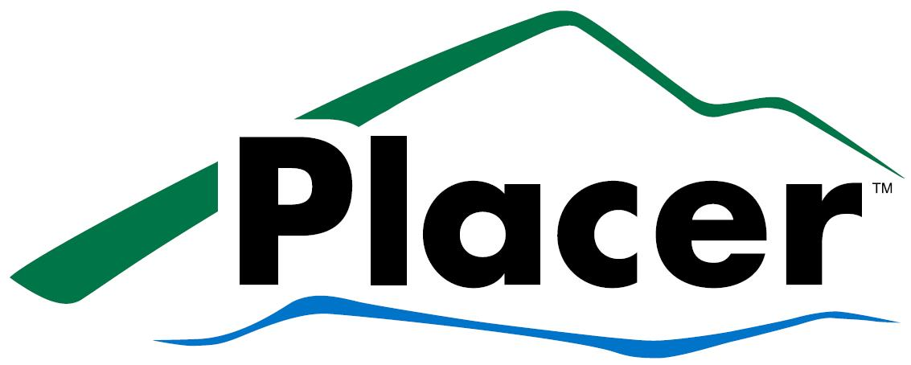 | 

Quality Assessment and Performance Improvement Work Plan
FY2022-23
Contents
PLACER DRUG MEDI-CAL ORGANIZED DELIVERY SYSTEM (DMC-ODS) BACKGROUND 4
PLACER/SIERRA MENTAL HEALTH PLAN (MHP) BACKGROUND 4
SIERRA COUNTY STATE PLAN (SUD) BACKGROUND 4
PLACER COUNTY OVERVIEW 4
SIERRA COUNTY OVERVIEW 5
PLACER COUNTY QUALITY MANAGEMENT ORGANIZATION CHART 5
SIERRA COUNTY QUALITY MANAGEMENT ORGANIZATION CHART 6
PLACER/SIERRA ANNUAL QUALITY ASSURANCE MONITORING ACTIVITES 6
PLACER COUNTY CURRENT INITIATIVES 9
PLACER COUNTY ANNUAL QUALITY IMPROVEMENT AND CULTURAL COMPENTENCE WORK PLAN 12
Population Assessment and Utilization Data 12
Goal 1: Improve documentation of calls received by the 24/7 Access Lines logged in the EHR. 12
Goal 2: Ensure diverse representation of staff, consumers, stakeholders and community partners within the Placer READI Committee 12
Goal 3: Identify gaps and disparities in service delivery to improve client engagement. 12
Staff/Personnel Development and Training 13
Goal 4: Improve completion of assigned Compliance Trainings and a minimum completion of one (1) Cultural Competence training per year. 13
Goal 5: Consumer/Family Participation on Interview Panels for Eligible Interviews, for candidates applying to be a county behavioral health provider for the MHP. 13
Goal 6: Continue to Integrate Native American/American Indian and Latino Services Team into CSOC. (MHP) 13
Goal 7: Improve staff and contractor retention and satisfaction 14
Goal 8: Ensure all SUD Providers are properly trained prior to service delivery. 14
Service Delivery and Care Coordination 14
Goal 9: Administer LOCUS with fidelity to all eligible adult clients in the MHP as appropriate. 14
Goal 10: Increase Chart Review compliance for quality improvement indicators for the SOC. 14
Goal 11: Track and Trend Medication Monitoring indicators related to SB 1291 for youths that qualify within each indicator. 15
Goal 12: Increase linkage to service providers and engagement in treatment of clients needing intensive outpatient SUD 15
Goal 13: Achieve 100% CANS Certification 15
Access and Timeliness 15
Goal 14: Improve or maintain access and timeliness measurements for all indicators. 15
Satisfaction 16
Goal 15: Improve the documentation of grievance calls logged into the EHR by call center staff. 16
Mental Health Service Act (MHSA) 16
In-Home Supportive Services 16
Goal 16: Complete IHSS CFCO Reassessments Timely 16
Child Welfare Services 16
SIERRA COUNTY ANNUAL QUALITY IMPROVEMENT WORK PLAN 17
Population Assessment and Utilization Data 17
Goal 1: Ensure Access to Services telephone lines are providing linguistically appropriate services to callers. (MH) 17
Staff/Personnel Development and Training 17
Goal 2: Maintain 100% staff participation in trainings and presentations. (MH/AOD) 17
Service Delivery and Care Coordination 17
Goal 3: Upgrade Telehealth Technology (MH/AOD) 17
Goal 4: Increase Provider Productivity and Caseload reporting (MH) 17
Goal 5: Increase Faith Based Community Attendance in the Community Planning Process (MH) 18
Goal 6: Establish Process Groups for SUD beneficiaries (AOD) 18
Goal 7: Ensure every beneficiary that receives services in Behavioral Health is informed of the Wellness Center (MH/MHSA) 18
Access and Timeliness 18
Goal 8: Improve attendance of SUD beneficiaries in treatment (AOD) 18
Goal 9: Improve access and timeliness of services. (MH) 19
Goal 10: Increase completion of Client Perception Surveys administered as required by DHCS semi-annually. (MH) 19

PLACER DRUG MEDI-CAL ORGANIZED DELIVERY SYSTEM (DMC-ODS) BACKGROUND
Placer launched its Drug Medi-Cal Organized Delivery System (DMC-ODS) in November 2018 for Medicaid (Medi-Cal) recipients as part of California’s 1115 DMC Waiver. The Drug Medi-Cal Organized Delivery System (DMC-ODS) is a State Pilot to test a new paradigm for the organized delivery of health care services for Medi-Cal eligible individuals with substance use disorders. Placer was the 23rd county in California to implement the DMC-ODS and one of 14 counties statewide to launch in 2018.

PLACER/SIERRA MENTAL HEALTH PLAN (MHP) BACKGROUND
Between 1995 and 1998, the State consolidated fee-for-services and Short Doyle/Medi-Cal programs into one specialty mental health managed care program, and under the system of all Medi-Cal specialty mental health services were “carved out” of Medi-Cal and became the Counties’ responsibility. Medi-Cal beneficiary access to mental health services became available through the county Mental Health Plan (MHP). Placer County’s MHP was implemented on November 1, 1997. Sierra County became part of Placer County’s MHP on April 1, 1998.
The Placer/Sierra MHP is unique in that Placer and Sierra County do not share borders, staff, or beneficiaries. Together, we coordinate program quality assurance, quality improvement, and compliance to benefit consumers from each county and maintain a high standard of services. The Placer/Sierra MHP is administered by the Director of the Adult Systems of Care who reports to the Health and Human Services Director.

SIERRA COUNTY STATE PLAN (SUD) BACKGROUND
Sierra County has been approved for reimbursement from the Drug Medi-Cal State Plan for Substance Use Disorders during Fiscal Year 2019-2020. Sierra County was one of the last counties to bill Drug Medi-Cal for Substance Use Disorder (SUD) services.

PLACER COUNTY OVERVIEW
Placer County encompasses 1,506 square miles (including 82 square miles of water) or 964,140 acres (including 52,780 acres of water) and is located 80 miles northeast of San Francisco, California. It is bordered by Nevada County to the north, the State of Nevada to the east, El Dorado and Sacramento Counties to the south, and Sutter and Yuba Counties to the west. The County is part of the Sacramento Region, which also includes the Counties of El Dorado, Sacramento, Sutter, Yolo, and Yuba. The government center of Placer County, the City of Auburn, is located 30 miles northeast of the state capitol, Sacramento.

SIERRA COUNTY OVERVIEW
Sierra County encompasses a total area of 962 square miles, including 9.0 square miles of water and is the second least populous county in California. Sierra County is located in the Sierra Nevada, northeast of Sacramento on the boarder of the State of Nevada. It is bordered by Plumas and Lassen Counties to the north, the State of Nevada to the east, Nevada County to the south and Yuba County to the west. The County is part of North-Central Sierra Nevada Region, which also includes the counties of Tehama, Butte, and Plumas. The county seat, Downieville, is located on Highway 49 at the fork of the North Yuba and Downieville River with the second most populous municipality, Loyalton, being the only incorporated city in the County.

PLACER COUNTY QUALITY MANAGEMENT ORGANIZATION CHART
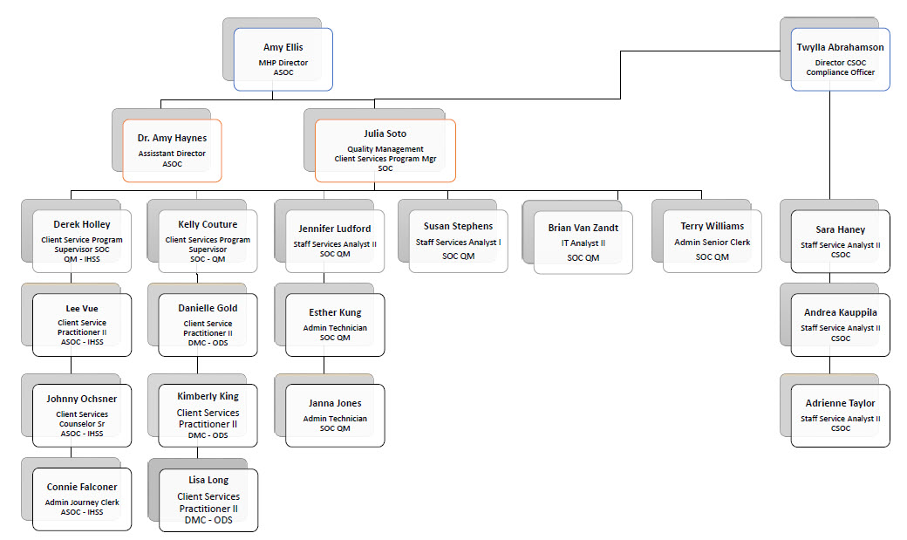

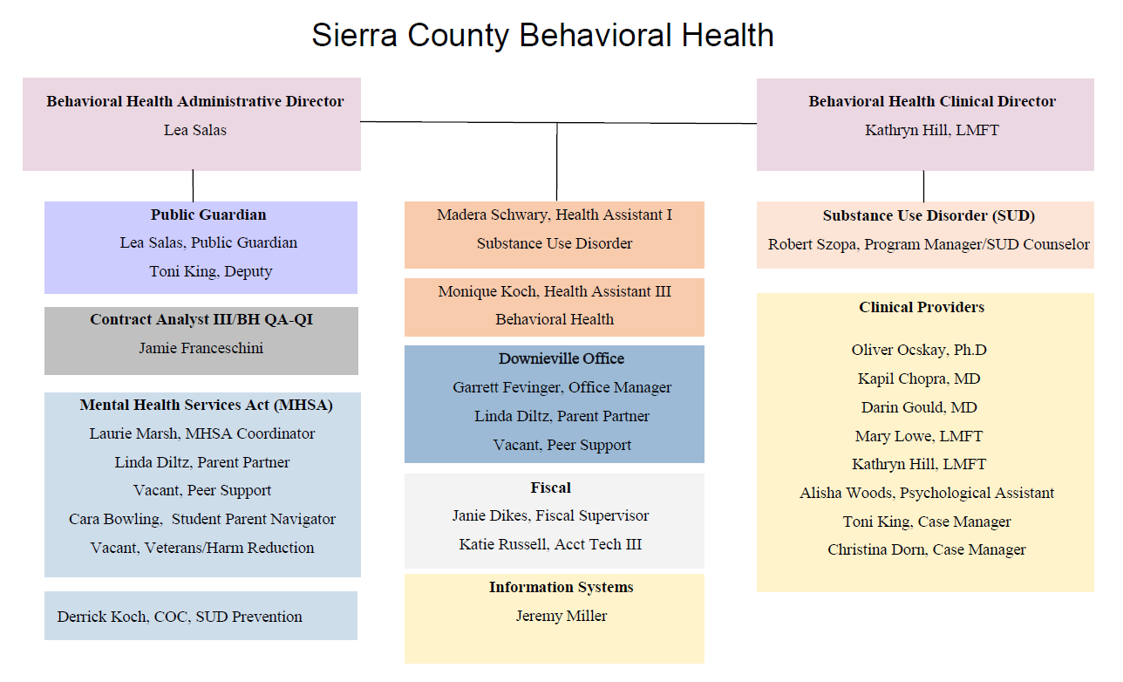
SIERRA COUNTY QUALITY MANAGEMENT ORGANIZATION CHART

PLACER/SIERRA ANNUAL QUALITY ASSURANCE MONITORING ACTIVITES
The MHP/ODS shall conduct performance monitoring activities throughout the Systems of Care, which includes both previously identified quality of care issues, as well as those which are identified as quality improvement activities. These activities shall include, but are not limited to, beneficiary and system outcomes, utilization management, utilization review, provider appeals, credentialing and monitoring, and resolution of beneficiary grievances. The purpose is to determine baselines for performance improvement projects, collect and submit performance measurement, have mechanisms in place to detect both underutilization and overutilization of services, and mechanisms to assess the quality and appropriateness of care furnished to beneficiaries with special health care needs. The SOC monitors items within quality improvement, quality assurance, and compliance and the SOC takes appropriate follow up action as determined by the Quality Improvement Committee when any occurrence is identified that may affect the quality of our programs. The results of these interventions are evaluated annual, at a minimum.

- The SOC has implemented mechanisms to monitor appropriate and timely intervention of occurrences that raise quality of care concerns.
- The SOC has implemented mechanisms to monitor the safety and effectiveness of medication processes under the supervision of the Chief Psychiatrist/Medical Director or designee, at least annually.
- The SOC has implemented mechanisms to monitor and review beneficiary grievances, appeals, fair hearings, expedited fair hearings, provider appeals, which are reviewed and discussed quarterly, at a minimum at the monthly QM Meeting. Results of this review is reported to QIC for discussion and guidance if necessary.
- The SOC has implemented mechanisms to monitor and assess how beneficiary complaints data will be collected. Information is reviewed and trained for:
  - How to submit a grievance, appeal, and request for state hearing
  - The time frame of resolution of appeals
  - The content of an appeal resolution
  - Record keeping
  - Continuation of benefits
  - Requirements of state hearings
- The SOC has implemented mechanisms to assess beneficiary/family satisfaction by:
  - utilizing and implementing Consumer Perception Surveys (MHP)/Treatment Perception Surveys (ODS), as required by DHCS, at least annually, and informing stakeholder of survey results on an annual basis
  - evaluating beneficiary grievances, appeals and fair hearings, at least annually
  - evaluating requests to change providers, at least annually
- The SOC has implemented mechanisms to assess the accessibility of services within the service areas (both Placer and Sierra County, individually), which included:
  - Goals for responsiveness of the 24-hour toll-free telephone through the test call process, including use of language lines for prevalent non-English languages.
  - Goals for timeliness of scheduling of routine appointments, timeliness of services for urgent conditions, and access to after-hours care through the use of timeliness metrics, such as:
    - Timeliness of first initial contact to face-to-face appointment (MHP/ODS)
    - Frequency of follow-up appointments in accordance with individualized treatment plans (ODS)
    - Timeliness of services of the first dose of OTP/NTP services (ODS)
  - Access to after-hours care
  - Strategies to reduce avoidable hospitalizations
  - Coordination of physical and mental health services with waiver services at the provider level
- The SOC continues to monitor cultural and linguistic competence through regular reporting and feedback from Placer READI, formerly the Cultural Linguistic Competency Committee, to SOC planning, leadership and quality assurance committees (including but not limited to the Quality Improvement Committee, SOC Leadership Committees, SOC Staff Development, and Workforce Education and Training), and through client perception and workforce surveys, cultural competence training completion rates, and integration of Latino and Native organization providers in CSOC Community leadership and targeted workgroups in order to identify, implement and track system improvements needed for these populations.
- The SOC continues to have active Performance Improvement Projects (PIPs) which have contributed to meaningful improvement in clinical care and beneficiary service for both the MHP and DMC-ODS with each program having a clinical and non-clinical PIP active annually, for a total of four (4) required PIPs for the SOC.
- The SOC has implemented mechanisms to monitor the SOC service delivery system with the aim of improving the processes of providing care and better meeting the needs of SOC beneficiaries. This includes monitoring the number, type, and geographic distribution of each county’s delivery system
- The SOC has implemented mechanisms to maintain and monitor a network of appropriate providers that is supported by written agreements for subcontractors and that is sufficient to provide adequate access to all services covered under contracts with DHCS for all beneficiaries, including those with limited English proficiency of physical or mental disabilities.
- The SOC has implemented mechanisms to monitor network providers on a regular basis to determine compliance with timely access requirements and track and trend contractor data to accurately represent services.
- The SOC has established and implemented procedures and a system with dedicated staff for routine internal monitoring and auditing of compliance risks, prompt response to compliance issues as they are raised, investigation of potential compliance problems as identified in the course of self-evaluation and audits, correction of such problems promptly and thoroughly (or coordination of suspected criminal acts with law enforcement agencies) to reduce the potential for recurrence, and ongoing compliance with the requirements under contracts with DHCS.

Sierra County AOD State Plan Monitoring Activities:
- Sierra County has implemented mechanisms to monitor the status of all subcontractors on a monthly basis to ensure they maintain active enrollment in the DMC program
- Sierra County has implemented mechanisms to monitor recertifications as triggered through monthly status checks, including but not limited to; change in ownership, change in scope of services, remodeling of facility, or change in location and report any triggering events

PLACER COUNTY CURRENT INITIATIVES
The SOCs continue to provide new and forward-thinking services to beneficiaries through innovation and grant funding opportunities. As these initiatives are in various stages of implementation, it has not been determined if each will require monitoring or quality improvement measures.

Current initiatives include:

CalAIM implementation: Implementation of CalAIM initiatives is underway and Placer is expected to meet CalAIM milestones without issue. Placer QM has been providing ongoing technical assistances to programs and sub-contracted providers via hosted webinars and trainings and is leveraging the support offered by CalMHSA with their Learning Management System and office hours. Currently documentation reform initiatives are being rolled out including changes to problem lists and progress notes. Providers who may join the SmartCare EHR will benefit by leveraging the system for future milestones, including payment reform and data sharing. Those that do not join will be required to demonstrate compliance with their own EHR system. As Placer is relying on SmartCare to meet several future milestones, current EHR initiatives will be cancelled, and resources moved to SmartCare.

Crisis Care Mobile Unit (CCMU): The CCMU is the newest iteration of Mobile Crisis Triage/Family Mobile Teams. The CCMU combines the resources of both ASOC and CSOC to create a unified team that can provide services from child/youth through older adult. Placer started in 2014 with a Mobile Crisis Triage team which was comprised of pairs of clinical staff and peers and has grown over the years to include a registered nurse in 2019. That same year, the Children’s System of Care created the Family Mobile Team unit which provided services to child/youth/families who required care in the field. These teams continued to reduce crises in the field and reduce total time law enforcement was held on mental health related calls.

Families First Prevention Services Act (FFPSA) – Part I – Evidence-Based, Mental Health Preventive Services: The FFPSA passed in February of 2018 as part of the Bipartisan Budget Act. This federal law amends existing provisions within Title IV-B and IV-E of the Social Security Act. It creates new options for providing evidence-based, mental health preventive services that should prove to be very useful once additional guidance and funding is received from CDSS. Placer County has sent in a non-binding “opt in” letter indicating our intention to apply for funding and utilize these funds for the expanded youth and families who will be eligible. The requirement for who can be served has a narrow “candidacy” definition; however, additional caseworker resources will still be needed to carry out the entire range of FFPSA mandates.

FFPSA – Part IV – Assessments by Qualified Individuals: Part IV of the FFPSA creates new requirements for foster care placement settings. It has been implemented in California commencing October 1, 2021, with massive fiscal implications to Title IV-E funding. These placement settings are termed “Qualified Residential Treatment Programs” (QRTPs). These QRTPs are similar to Short-Term Residential Therapeutic Programs (STRTPs) under California’s Continuum of Care Reform (trauma informed, serves the most serious disorders, accredited by CARF, JCAHO, CoA) but also require nursing services to be available 24/7. These nurse-driven services have been approved by the state to be provided via telehealth to assist STRTP providers to remain open and delivering services. Training for Behavioral Health entities on how Qualified Individuals are to conduct assessments is an important part of implementing FFPSA Part IV.

FFPSA – Part IV – High Fidelity Wraparound: All youth stepping down from an STRTP must now be provided with up to six months of High-Fidelity Wraparound services to assist the transition. This family-based aftercare support must be provided to the child/non-minor dependent (NMD) exiting an STRTP placement. In California, High Fidelity Wraparound will be utilized to meet this requirement. Placer County currently has an established Wraparound program operated internally and one contractor providing a lower-level Wraparound model called Fast Track Wrap. Placer County has contracted with the University of Washington, Wraparound Evaluation and Research Team (WERT) to be able to enter data about Wraparound implementation / process with families into their WrapStat database. WrapStat is a data management system designed to assess fidelity of the Wraparound care model through the use of the Wraparound Fidelity Assessment System (WFAS). The WFAS is designed to be able to download the data for three fidelity tools (i.e., the WFI-EZ, TOM 2.0, and DART) and to house information about all of the youth within Wraparound care in order to provide a comprehensive look at the success and fidelity of the Wraparound program. Placer Wraparound has begun to use these tools, and the Fast Track Wrap provider currently utilizes components of these outcome tools as part of their internal data collection. In the next year, Placer County plans to review whether or not the provider will also be required to utilize the WrapStat data management system. In addition, the Placer Wraparound team and the Fast Track Wrap team will be utilizing the UC Davis Resource Center for Family-Focused Practice, and any other resources, for training and increasing fidelity within the Wraparound models in Placer County.

Lilliput Kinnections: Placer County CSOC has joined a multi-agency partnership with Lilliput/Wayfinder Family Services, the California Department of Social Services, four other California county child welfare/behavioral health agencies, and the Children’s Bureau funded through a 3-year Federal Demonstration Project grant. The project seeks to build credible evidence of the effectiveness of Kinship Navigator (KN) programs in supporting kinship caregivers through increased knowledge of, referrals to, and access to needed services, including behavioral health, with the ultimate goal of improving child welfare outcomes for youth being raised in kinship care. The proposed project supports the implementation and evaluation of a well-established, existing KN program that aims to meet the criteria and standards in the Handbook of Standards and Procedures, contribute to the research reviewed by the Title-IV-E Prevention Services Clearinghouse, and create a pathway for Title IV-E funding through FFPSA for states that are implementing KN programs. A rigorous, independent evaluation will be conducted by Child Trends, a nonprofit research organization that provides science-based information to improve the decisions, programs, and policies that affect children and their families.
Lotus: In September 2022 Placer County launched a Behavioral Health Urgent Care center for adults called Lotus. In this short-term program, clients can be dropped off or self-referred in a quick and simple entry process designed to be low barrier and prioritize admission. The center is open to everyone in the county regardless of insurance type and will provide interventions and emphasis on linkage to follow up care. This service is getting high praise from both hospitals and law enforcement partners as a wonderful service to our community.

SmartCare EHR Transition: As CalAIM progresses and future milestones are targeted, Placer has made the decision to transition to a new Electronic Health Record (EHR). The new EHR, SmartCare is a CalMHSA spearheaded EHR that many counties will be joining. This transition will allow Placer to not only achieve compliance and meet future milestones, but it will also allow Placer to move to the next level in data collection and reporting.

Wellness Center: The Wellness Center is a Peer-run program where members of the community find a supportive, informative, and uplifting drug and alcohol-free environment. Our Wellness Center is rooted in the Strengths Model, which is an evidence-based practice that utilizes each person’s unique talents, skills, knowledge, interests, and other resources to help improve mental health and overall wellness. The Center primarily serves Placer County individuals and families experiencing mental health issues and/or homelessness. The Wellness Center provides social engagement as well as skill-building groups and activities to address daily living, job skills, and creative expressions. Groups and classes are designed and facilitated by Peer Advocates and AMI Housing staff to meet the needs of the guests we serve.

Youth First Demonstration Project/Complex Care: Youth First is a demonstration project that seeks to identify innovative program designs that meet the needs of youth with complex challenges, focused on individualized trauma-informed services and supports with a goal of placement permanency. The project is designed to build on existing Intensive Services Foster Care and STRTP placement categories for funding innovation, while creating a learning community for provider and county participants to design programs, staffing models, clinical practices, and funding sources to creatively support individualized treatments and family-based care placements for youth with complex needs. Evaluation of these efforts is also a component of the Youth First Pilot to ensure replicability and the ability to scale up the models. Placer applied for and was selected with a few other counties to be a part of this Enhanced Care Program planning effort along with several local providers.

PLACER COUNTY ANNUAL QUALITY IMPROVEMENT AND CULTURAL COMPENTENCE WORK PLAN
The QIC is responsible for the annual DMC-ODS, MHP, and other SOC work plans as well as the annual work plan effectiveness reports. The DMC-ODS and MHP review the work plan with key stakeholders and members of the QI subcommittee of the Mental Health, Alcohol and Drug Advisory Board. QIC reviews the annual work plan and its effectiveness annually during the External Quality Review Organization review, and the DMC-ODS annual review, and every three years during the Department of Health Care Services Triennial review. The QIC will submit the annual plan and effectiveness reports to Department of Health Care services on an annual basis and are available on the Placer County Website at https://www.placer.ca.gov/6019/Behavioral-Health-Quality-Management.

Population Assessment and Utilization Data

Improve documentation of calls received by the 24/7 Access Lines logged in the EHR.
Objectives:
- Maintain a minimum of 36 test calls annually (8 non-English, including TTY) (MHP)
- Improve documentation/logging for all calls and of logging all required elements (Name, Date, Time, Purpose/Resolution) to a minimum of 80% for all calls received. In FY2021/22, 81.82% of MHP and 100% ODS were logged. (MHP/ODS)
- Maintain a minimum of 12 test calls annually (4 non-English, including TTY) (ODS)

Ensure diverse representation of staff, consumers, stakeholders and community partners within the Placer READI Committee
Objectives:
- Complete Placer READI participant demographic survey semi-annually and create outreach opportunities and strategies to engage any identified unrepresented community members and partners.
- Maintain 80% attendance by member agencies/community partners. (CC)

Identify gaps and disparities in service delivery to improve client engagement.
Objectives:

- Placer READI Committee will review client and beneficiary demographic data at least annually to identify underserved populations and make recommendations to the quality improvement committee to address such.
- Review SOGI data at least semi-annually for adult beneficiaries receiving outpatient mental health services from the Auburn and Roseville ASOC clinic locations, and review results of SOGI PIP beneficiary short survey results (pre intervention and 6-months post intervention), in order to monitor utilization of new fields and potential changes in beneficiary experience.
- Review feedback gathered from Placer READI Ambassadors at least quarterly and provide summary of results and any recommended follow-up to quality improvement and SOC leadership committees.
- Placer READI will identify, review, and propose trainings to the WET committee and SOC Development committee to bring increased competence and awareness to our MHP and ODS providers related to outcomes of above three (3) activities.

Staff/Personnel Development and Training

Improve completion of assigned Compliance Trainings and a minimum completion of one (1) Cultural Competence training per year.
Objectives:
- Ensure that each credentialed staff member (ODS and MHP staff) participates in and completes at least one training that meets the Culturally and Linguistically Appropriate Services (CLAS) National Standards within the year at a 90% target. (MHP/ODS)
- Work with cultural brokers and peers to develop county staff training or experiences. (MHP/ODS)
- Ensure that each staff member (County staff, ODS and MHP staff) completes required compliance trainings, such as Beneficiary Protection, Documentation Training, Golden Thread, and other program specific required compliance trainings. (MHP/ODS)

Consumer/Family Participation on Interview Panels for Eligible Interviews, for candidates applying to be a county behavioral health provider for the MHP.
Objective(s):
- Establish a monitoring mechanism to track consumer/family participation for eligible interviews.
- Maintain a combined minimum of consumer/family participation on 50% of eligible interviews. (MHP) (FY2021/22: 5%)

Continue to Integrate Native American/American Indian and Latino Services Team into CSOC. (MHP)
Objectives:
- Ensure greater than 70% of identified Native youth placed in homes with non-Native caregivers in Placer County shall be referred to Sierra Native Alliance to develop youth-specific plans in order to create a culturally supportive placement.
- Provide at least one training to staff on effective collaboration with cultural brokers for direct service.
- Monitor and evaluate the number of moves and satisfaction with placement for youth who complete a placement survey to determine the effectiveness of promoting voice and choice in the selection of a placement.
- On an annual basis, evaluate the effectiveness of connected families to cultural brokers (SNA and LLC), as measured by Perception of Care Survey results for families served. Implement process to record referrals from CSOC to SNA and/or LLC.

Improve staff and contractor retention and satisfaction
Objectives:
- Identify discrepancies in pay structure to retain staff (MHP)
- Survey the workplace to determine ways to provide better staff satisfaction (MHP)
- Survey the contracted providers to determine best ways to increase provider satisfaction (MHP)

Ensure all SUD Providers are properly trained prior to service delivery.
Objectives:
- Establish a system to monitor each training requirement. (ODS)
- Review monitoring reports with stakeholders at least semi-annually to ensure completion of all required trainings. (ODS)
- Ensure 100% of SUD Providers complete required trainings based on scope of staff credentialling. (ODS)

Service Delivery and Care Coordination

Administer LOCUS with fidelity to all eligible adult clients in the MHP as appropriate.
Objectives:
- Increase the total percentage of completed LOCUS Assessments for eligible adult clients (MHP)
- Increase number of adult clients who have received a LOCUS rating/evaluation within 90 days of treatment planning from 68.4% to 75% by end of FY. (MHP)
- Increase the percentage of adult clients who had a LOCUS completed within 90 days of planned discharge from 7.5% to 15%. (MHP)

Increase Chart Review compliance for quality improvement indicators for the SOC.
Objectives:
- Create a system that will identify and trend chart review indicators for MHP and ODS providers including ASOC and CSOC clinics. Review this data with stakeholders bi-annually. (MHP/ODS)
- Maintain 90% compliance in charting indicators across the MHP and ODS including ASOC and CSOC clinics, individual network providers, and contracted providers. (MHP/ODS)
- Conduct a minimum of 2 ASOC/CSOC supervisor training sessions to review charting indicators. (MHP/ODS)
- Maintain number of ASOC/CSOC charts reviewed with no corrections required to a minimum of 85%. Prior FY was 52.4%. (MHP)

Track and Trend Medication Monitoring indicators related to SB 1291 for youths that qualify within each indicator.

Objectives:
- Establish a system to monitor, track, and trend Follow-Up Care for Children Prescribed Attention Deficit Hyperactivity Disorder Medication (HEDIS ADD). (MHP)
- Establish a system to monitor, track, and trend Use of Multiple Concurrent Antipsychotics in Children and Adolescents (HEDIS APC). (MHP)
- Establish a system to monitor, track, and trend Use of First-Line Psychosocial Care for Children and Adolescents on Antipsychotics (HEDIS APP). (MHP)
- Establish a system to monitor, track, and trend Metabolic Monitoring for Children and Adolescents on Antipsychotics (HEDIS APM). (MHP)

Increase linkage to service providers and engagement in treatment of clients needing intensive outpatient SUD
Objective: Increase linkage to service providers and engagement in treatment of clients needing intensive outpatient SUD Tx from 0% to 20%. (ODS)

Achieve 100% CANS Certification
Objectives:
- Maintain the percentage of MHP staff completing CANS who are properly certified via the Praed foundation at 100%. (MHP)
- Establish a system to monitor training requirement for all MHP providers. (MHP)
- Review monitoring report every 6 months with stakeholders. (MHP)

Access and Timeliness

Improve or maintain access and timeliness measurements for all indicators.
Objectives:
- Decrease number of acute admission episodes [psych inpatient and Psychiatric Health Facility (PHF)] that are followed by a readmission within 30 days during a one-year period in a FY from 15.41% to 10%. (MHP)
- Improve percentage of acute discharges [psych inpatient and Psychiatric Health Facility (PHF)] that receive follow-up outpatient contact (face to face, telephone, or field-base) within 7 days of discharge from 64.38% to 75%. (MHP)
- Maintain the percentage of non-urgent mental health service appointments completed within 10 business days of the initial request for an appointment at 90%. FY2021/22 was 98.4% for all ages combined. (MHP)
- Improve the percentage of non-urgent medication support appointments offered (or completed) within 15 business days of the request for an appointment from 63.3% to 70%. (MHP)
- Improve the percentage of clients screened to a residential level of care that receive an interim service within 3 days for urgent needs from 80.9% to 85% for urgent. (ODS)
- Improve the percentage of clients screened to a residential level of care that receive an interim service within 7 days for non-urgent needs from 84.2% to 90% (ODS)
- Establish a process to collect no-shows (DKAs) by clinical staff (MHP)
- Improve the percentage of clients that receive follow-up appointments with Placer clinic staff following a Placer screening with the intent to improve treatment linkage success. (ODS)
- Improve the percentage of clients that receive follow-up appointments with Placer clinic staff following discharge from Residential treatment with the intent of increased recovery services utilization. (ODS)

Satisfaction

Improve the documentation of grievance calls logged into the EHR by call center staff.
Objectives:
  - Test the Call Centers for knowledge of the Beneficiary Grievance and Appeals Process at a minimum of 12 test calls per fiscal year. (MHP/ODS)
  - Increase documentation of all logging elements (Name, Date/Time, Purpose/Resolution) to a minimum of 75% (Prior FY was 66.67% MHP; 0% for ODS) for all calls received based on test call results. (MHP/ODS)

Mental Health Service Act (MHSA)
Please refer to the MHSA 3-Year Plan and/or MHSA Annual updates at the links below.
Mental Health Services Act | Placer County, CA

In-Home Supportive Services

Complete IHSS CFCO Reassessments Timely
Objective: Maintain the reassessment rate for CFCO reassessments at 90% (FY2021/22 was 92.3%)

Child Welfare Services
Please refer to the Children’s System of Care System Improvement Plan at the link below.
CDSS: System Improvement Plan Progress Reports (ca.gov)

SIERRA COUNTY ANNUAL QUALITY IMPROVEMENT WORK PLAN

Population Assessment and Utilization Data

Ensure Access to Services telephone lines are providing linguistically appropriate services to callers. (MH)
Objectives:
  - Maintain a minimum of 12 test calls annually to ensure staff provides linguistically appropriate services to callers and are utilizing the Tele-language Translation line service.
  - Maintain a minimum of 4 non-English test calls on an annual basis.

Staff/Personnel Development and Training

Maintain 100% staff participation in trainings and presentations. (MH/AOD)
Objectives:
- Maintain that 100% of the Clinical Team completes the CalAIM/CalMHSA trainings to ensure documentation practices are contemporary with Medi-Cal billable services.
- Participation in trainings by Behavioral Health team members will be recorded and tracked. Focus will be on training supporting Quality Improvement related to services, cultural competence, and professional development. There will be monthly assignments to participate in trainings.

Service Delivery and Care Coordination

Upgrade Telehealth Technology (MH/AOD)
Objectives:
- Provide in-office telehealth kiosks/rooms which consist of laptops, monitors, and quality speakers that are user friendly, accessible, and ergonomically correct for beneficiaries utilizing telehealth.
- Administer surveys to measure beneficiary satisfaction regarding in-office telehealth technology.

Increase Provider Productivity and Caseload reporting (MH)
Objectives:
- Create and implement reports to capture and measure provider productivity due to reduced documentation time which will increase access to providers resulting in more time spent with beneficiaries.
- Create and implement caseload reports to better inform providers of their current caseload needs

Increase Faith Based Community Attendance in the Community Planning Process (MH)
Objectives:
- Establish relationships with and increase outreach to the Pastors/Leaders/Decision Makers of the Faith Based Community within Sierra County by inviting them to participate in the Community Planning process for the Mental Health Services Act
- Note their attendance and contribution in the MHSA Annual Update

Establish Process Groups for SUD beneficiaries (AOD)
Objectives:
- Establish process groups that involves a gathering of peers who are also in recovery and a facilitator to help guide the sessions that will be available for both male and female beneficiaries to have a safe and supportive environment for treatment. These are called process groups because the therapist is overseeing a long-term treatment progression where one session builds upon the other.
- Administer surveys to beneficiaries who access the process groups to ensure that they feel safe and supported and have a mechanism to provide feedback for improvement

Ensure every beneficiary that receives services in Behavioral Health is informed of the Wellness Center (MH/MHSA)
Objectives:
- Improve awareness of the Wellness Center by providing each beneficiary information on accessing services and supports at the Wellness Center at the time of completion of their intake packet and scheduling their appointment for services.
- Improve beneficiaries’ encouragement of use of this resource as an additional form of support.
- Create and implement reports to measure beneficiary utilization of Sierra County’s Wellness Centers.

Access and Timeliness

Improve attendance of SUD beneficiaries in treatment (AOD)
Objectives:
- Remove obstacles that may hinder attendance for SUD beneficiaries by increasing office hours and providing transportation to those who need it
- Offer and provide both in-person and telehealth services.
- Provide option of attending Process Groups
- Create and implement reports to track and trend cancellation and no-show rates to determine improvement on goals.

Improve access and timeliness of services. (MH)
Objectives:
- Review, modify, and track timeliness to services to bring Sierra County Behavioral Health in alignment with the CMS Final Rule requirements.
- Improve percentage of Foster Care non-urgent mental health appointments offered within 10 business days of the initial request for an appointment by 10%.
- Improve percentage of Foster Care psychiatric appointments offered within 15 business days of the initial request for an appointment by 10%.

Increase completion of Client Perception Surveys administered as required by DHCS semi-annually. (MH)
Objectives:
- Utilize peer staff or Quality Improvement staff to administer and assist with completing Consumer Perception Surveys with clients.
- Decrease the number of Consumer Perception Surveys left blank to a maximum of 20%.

